(A2) Broken Authentication and Some TryHackMe!
WebGoat - Authentication Bypasses
(Q) for Inspect, then find the security questions in HTML and edit them.
I added values, or answers to the questions so I could bypass the 2FA questions.
Before:
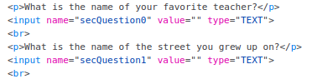
After:
Tried this and it didn’t work:
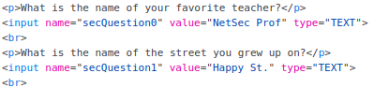
So, I tried this instead, with the help of https://pvxs.medium.com/webgoat-authentication-bypass-2-4eeb8e8b502b :
I probably could’ve left the values as secQuestion0 and secQuestion1 and fulfilled the field requirements by leaving the answers (the value field) as one word instead of words and characters like my previous answers.
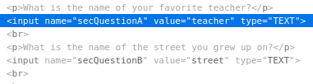
I successfully bypassed the 2FA security question practice!
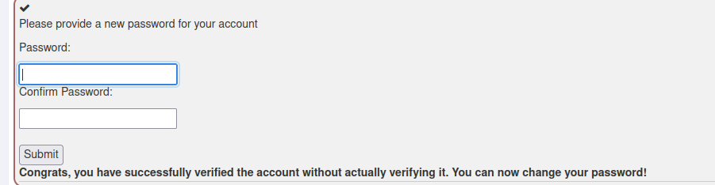
TryHackMe
Intro to Offensive Security
I am rusty at hacking, so I am taking the introduction course to brush up on my skills.
I launched the machine and then the terminal and entered this command:
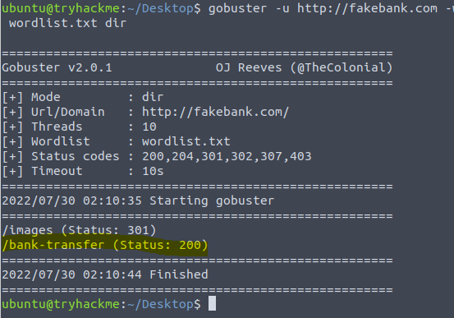
The command gave me information on where I can find an admin login for Fake Bank (the highlighted selection)
Through that I entered the URL fakebank.com/bank-transfer and got this:

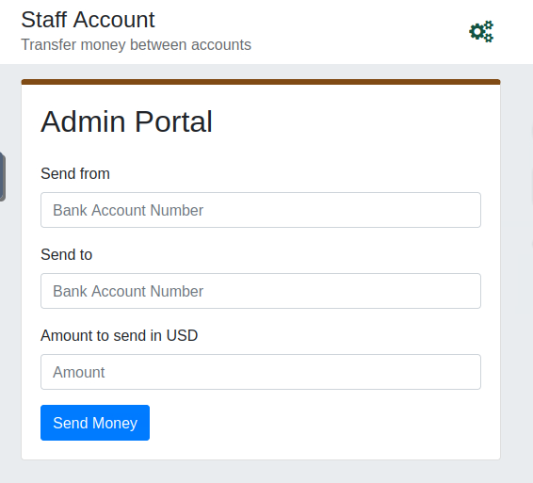
From here I transferred money from one account to my own.
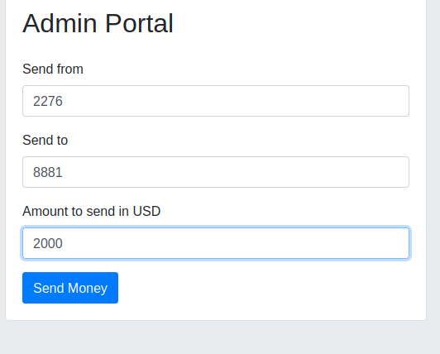
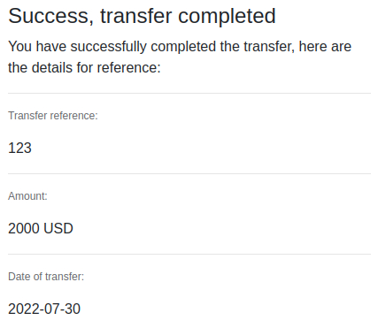
I successfully received the money.
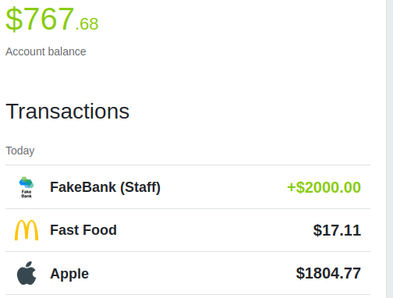
Answer to question (BANK-HACKED):
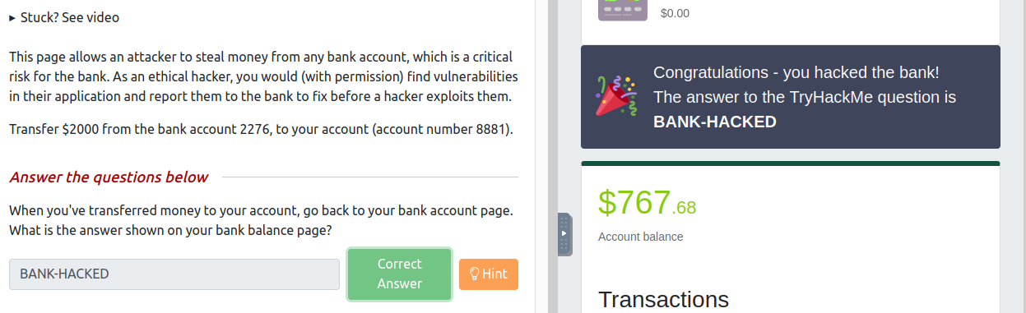
I finished the first hacking room!
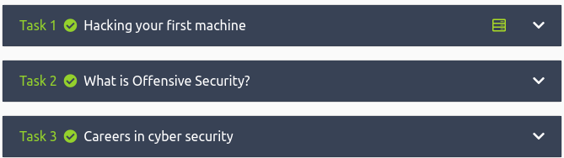
Web Fundamentals
(I’m going to start it so I can work on it in other assignments)
Walking an Application
Go to this website: https://10-10-70-236.p.thmlabs.com
Inspect the page (Q):
Find flag from HTML comment:
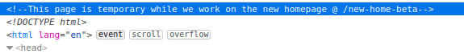
Went to: https://10-10-70-236.p.thmlabs.com/new-home-beta
The flag that appeared:
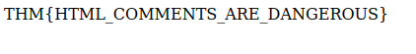
Find flag from secret link:
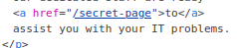
https://10-10-70-236.p.thmlabs.com/secret-page
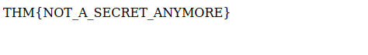
Directory listing flag:
What is /assets?
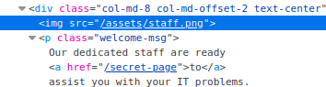
I found it, it’s the directory.
https://10-10-70-236.p.thmlabs.com/assets/
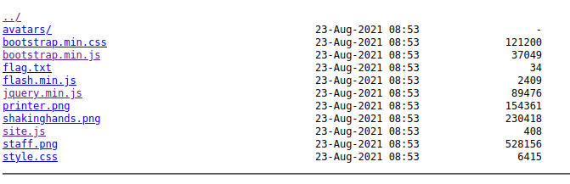
What about that flag.txt file? There we go.
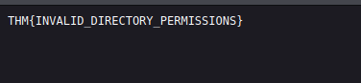
Framework flag:
This one was more difficult, I had to dig a little, but I found it.
I navigated to this website
https://static-labs.tryhackme.cloud/sites/thm-web-framework
Then clicked on the Change Log Tab:
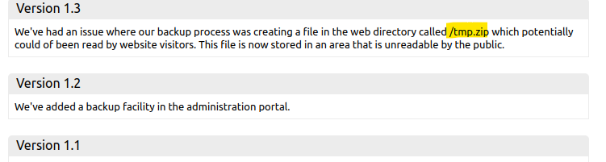
And then navigated to this website:
https://10-10-70-236.p.thmlabs.com/tmp.zip
Which downloaded a .zip that I unzipped and read in Mousepad
Which gave me this tag:
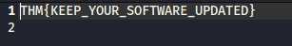
Finished: 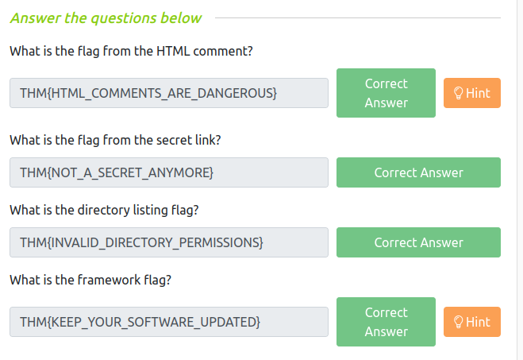

Notes:
Walking an Application
