Cyber Crime Report:
Republican Party Website Hacked
Emily Kellogg
University of Advancing Technology

A recent anti-abortion law in Texas received major backlash from pro-abortion activists. In response to the law’s legitimization, a hacktivist group defaced the Texas Republican Party’s Website. Along with breaking laws, the defacement raised ethical issues. Is there a good or bad guy in this situation? Not only will the details of the case be revealed, but also the laws broken, ethical issues that arose, and a Computer Security code of ethics.

The Case
“The website of the Republican Party of Texas was hacked and defaced over the weekend in apparent protest against the state’s controversial new abortion law” (Bannister, 2021). Recently, Texas passed a law called the Heartbeat Act which prohibits abortions past 6 weeks, when a heartbeat can be heard in utero. In response to the implementation of this Act, hacktivists vandalized Texas’ Republican Party website with various messages, memes, and an invitation for viewers to donate to Planned Parenthood (Bannister, 2021). It was not explicitly stated in the article who defaced the website. My assumption is that it was pro-abortion activists with possible connections to Anonymous, since a message on the defaced GOP’s website read “Anonymous is Legion” (Bannister, 2021).

Laws Violated
According to an article on the iPleaders’ website about punishment for website defacement, the main law violated by the hacktivists was the IT Act of 2000 (Pandey, 2017). There are two sections of the IT Act that specifically relate to tampering with a computer, but only one relates specifically to this case. That section is Section 66 of the IT Act of 2000, which states:
“…hacking with computer system is a cognizable act which is non-bailable and is triable by a first-class Magistrate…punishment includes…imprisonment of up to three years or with a fine of up to Rs.2 lakhs ($200,000) or with both” (Pandey, 2017).
What this law means is that if caught, the hacktivists could be facing time in prison and fees of up to $200,000. Unfortunately, with how intelligent Anonymous is, I am not sure that anyone will ever be caught.

Ethical Concerns
This case challenges my views of right and wrong because I do not believe in abortion, but I also do not believe the law should have been passed. In my opinion, Texas passed a law that infringes on the rights of pregnant women, and the hacktivists defaced a government website in response to it. So really, both sides are bad in my opinion. The only way I would consider the hacktivists to be the good guys is if they protested in a legal way, but they did not. Another issue I face is that I see the reasoning behind both sides of the argument. The act of aborting a child horrifies me to no end, so I can see why a law was passed to make it illegal. But it also infringes on a woman’s right to make that choice for herself, so I am stuck in the middle. Either way, both sides made an error and there is no good guy in this situation.

Code of Ethics

Self
Act in the best interest of yourself. Be ethical, humble, and have integrity. Treat yourself with respect.
For example, always look to further your knowledge of computer security, as it is constantly changing. Apply your knowledge of security to your everyday life.

Society
Act in the best interest of society and protect it. Remember your reputation in their eyes.
E.g., you are the security professional, not them. Teach society how to protect themselves.

Peers
Treat your peers as equals, not your competition or your enemies. Give them the respect you want to receive and treat them how you want to be treated. Have their back and they will have yours.
For example, help them when they are stuck, further their knowledge of security by sharing your experiences.

Product/Service
Make sure the product or service offered is of the highest standard and security. Do not treat is as just a product or service, but as the lifeblood of the company.
For instance, make sure all software/hardware is up to date with the latest updates and security. Ensure that it is running correctly and efficiently.

Customers
Act in the best interest of the customer, not your product or service. Teach them security so they can protect themselves. Treat them with respect and integrity. You serve them, not the other way around.
E.g., instead of focusing on selling your product or service, focus on what the customer needs.

Employment
Comply with laws and regulations regarding your career. Operate with integrity and remember your reputation (see Figure 1).
As an example, act according to your job description and what is expected of you. Remember that you are handling sensitive information, treat it as such.
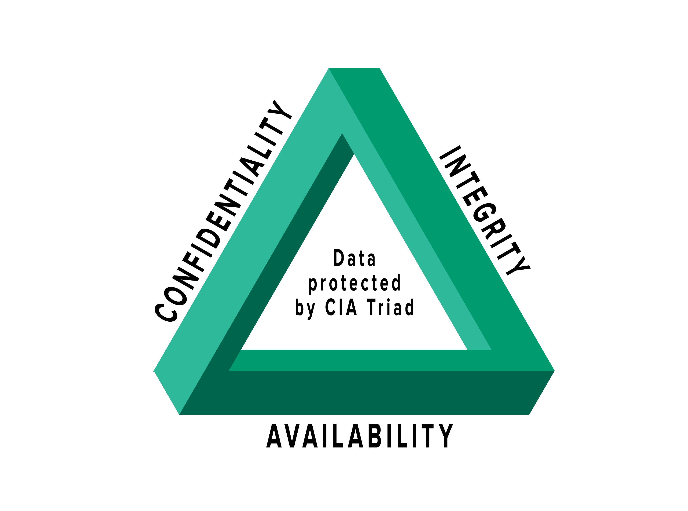
Figure 1: The CIA Triad

Bibliography
Bannister, A. (2021, September 14). Texas Republican Party Website Defaced in 'Anonymous' Protest Against Abortion Law. Retrieved from The Daily Swig: https://portswigger.net/daily-swig/texas-republican-party-website-defaced-in-anonymous-protest-against-abortion-law
IEEE. (n.d.). Code of Ethics. Retrieved from IEEE Computer Security: https://www.computer.org/education/code-of-ethics
Pandey, A. (2017, June 1). Punishments for Website Defacement. Retrieved from iPleaders: https://blog.ipleaders.in/defacement-legal-action/
Van Impe, K. (2021, January 8). Cybersecurity Ethics: Establish a Code for Your SOC. Retrieved from Security Intelligence: https://securityintelligence.com/articles/cybersecurity-ethics-establishing-a-code-of-conduct-for-soc/
Walkowski, D. (2019). The CIA Triad [Image]. What is the CIA Triad? Retrieved from https://www.f5.com/labs/articles/education/what-is-the-cia-triad.

