NetBroke Hands-On Final
- Turned on the main router (Kind of a big Deal) because it was off.
  - This fixed the connectivity issues between each device connected to said router.
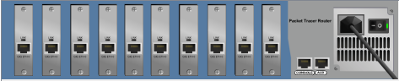
Before:
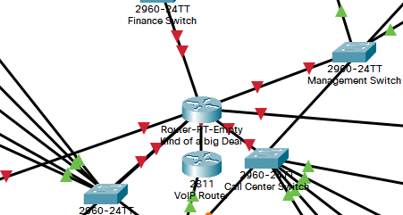
After:
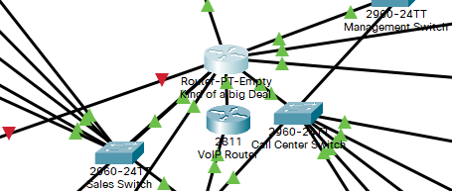
- Call Center PC1 could not access the internet.
  - What I had to do was go to the DHCP server and add another device to the Call Center pool because there was a max number of users set at 4 (when there were 5 devices total). I was then able to get the PC to retrieve an IP using DHCP.

Before and after images of the DHCP server pools. Note how the Call Center pool was increased to 5.
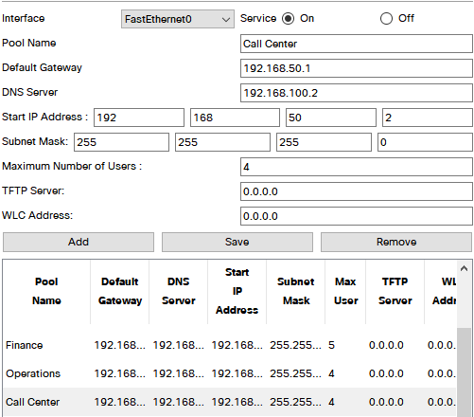
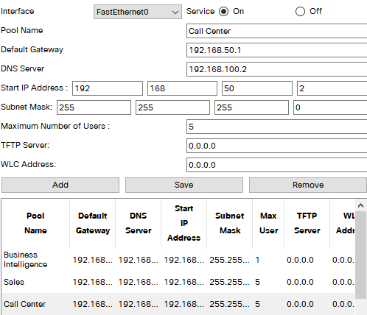

Before and after images of the Call Center PC1. Note how the IP config is now set to DHCP. When I would set it to DHCP before, it would default to APIPA. Now it is fixed.
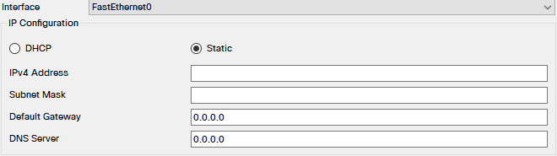
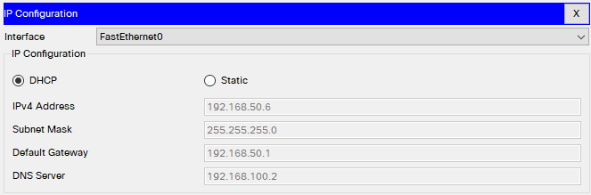
Call Center PC1 can now access the Internet.
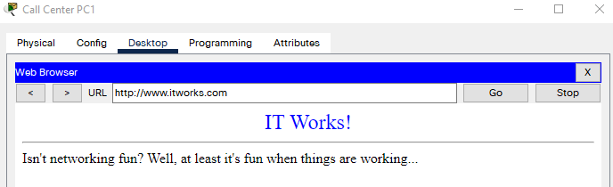
- Manager says his phone isn’t working. Let’s look…

Easy fix, the phone was unplugged.
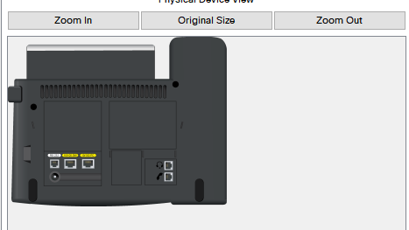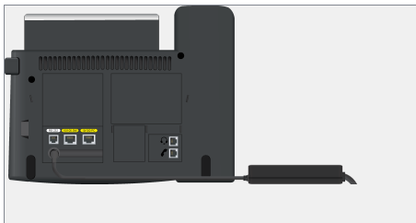

Before and after I plugged the phone in.
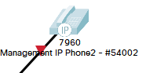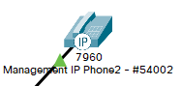

- Bill can’t reach the Internet…
Before and after I configured DHCP on Bill’s computer. It was the same issue with DHCP – not enough max users in the pool.
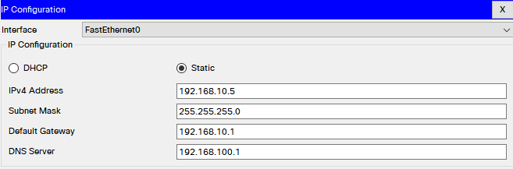
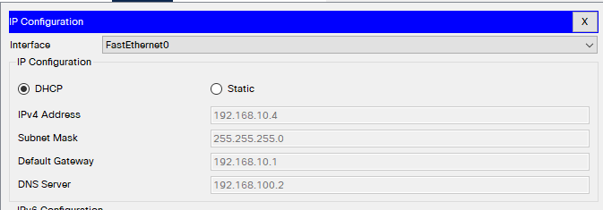
Another before and after photo. Since Bill is part of Sales, I added more max users to the pool (there are 5 devices in sales). I then went back to Bill’s PC and configured DHCP for him which is in the picture above.
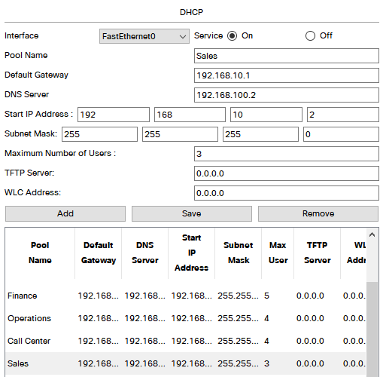
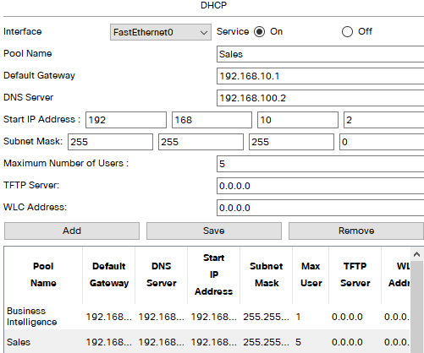
Proof that Bill’s computer can connect to the Internet!
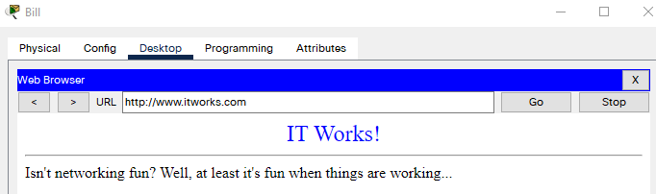
- Add Business Intelligence
There is Kiran and the Business Intelligence switch. The switch is connected to the Kind of a big Deal router.
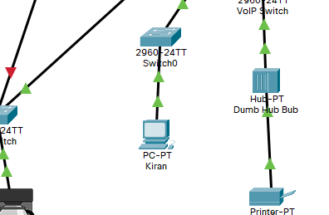

I added the Business Intelligence pool to the DHCP router so devices can be configured using DHCP.
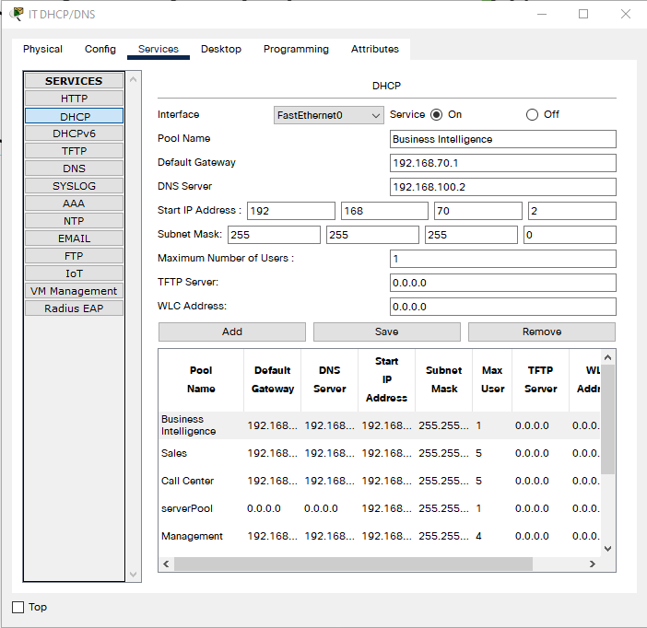

Here is Kiran’s PC configured with DHCP.
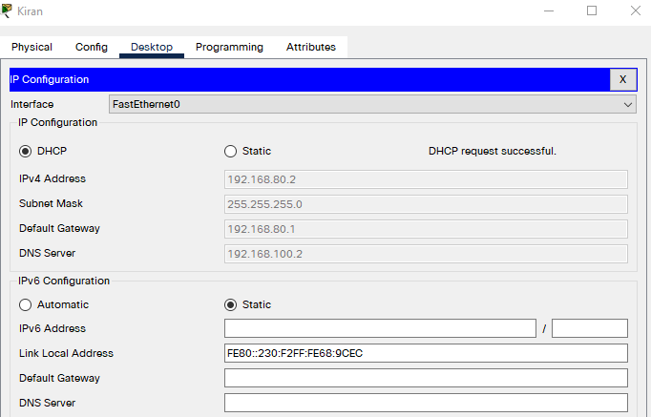

Kiran successfully pinged DNS.
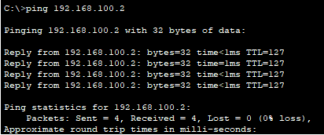

- Something is wrong with the coffee maker? Maybe you shouldn’t have such a high tech one, then.
It was off. I turned it back on.
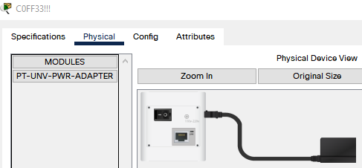
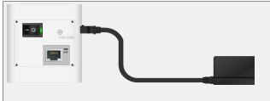
Now it’s working and connected!
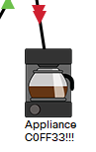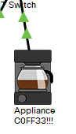

- No password on the router (Kind of a big Deal router)
Before password:

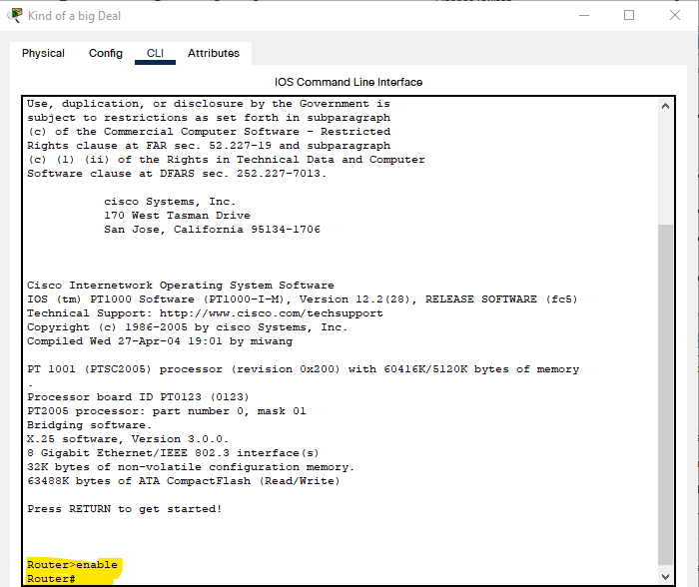
After password:

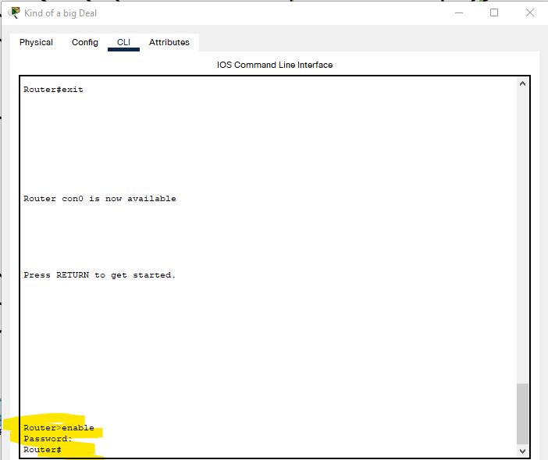
I lost my screenshots with all the coding steps for setting the password, so I hope this is sufficient.
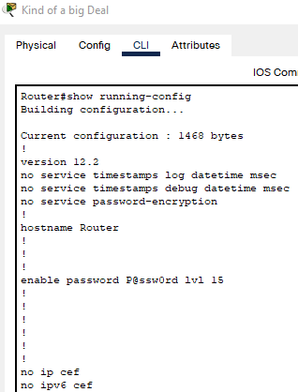
Probably should’ve made the password a secret since its out in the open like this… but hey, it works for the sake of this assignment.

- Copied the running config to the startup config.
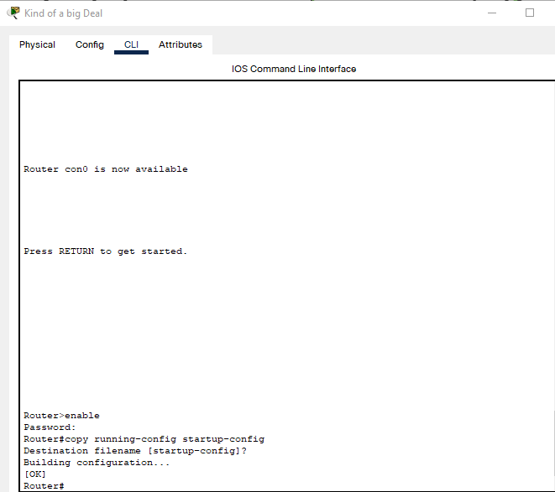

- WRT300N and a laptop

Look how pretty it is! The wireless connection is working flawlessly.
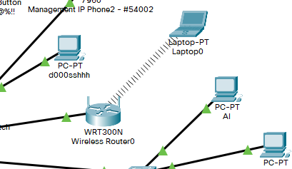

Laptop is configured.
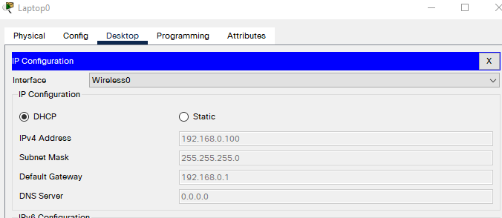

With WiFi (it’s in a wireless card)
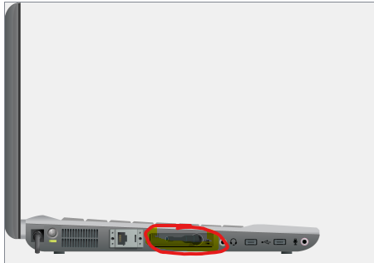

WPA2 Personal with PSK set up on the router
