Shodan Compilation
net:54.219.109.202,54.219.10.187,13.56.150.53,54.151.2.50,54.200.38.128,13.56.229.144,52.53.235.246,18.221.204.117,13.57.178.200,13.52.96.169,54.183.226.12,13.57.206.78,54.176.155.123,52.53.231.231,3.143.67.32,54.215.216.238,52.38.26.183
nmap 54.219.109.202,54.219.10.187,13.56.150.53,54.151.2.50,54.200.38.128,13.56.229.144,52.53.235.246,18.221.204.117,13.57.178.200,13.52.96.169,54.183.226.12,13.57.206.78,54.176.155.123,52.53.231.231,3.143.67.32,54.215.216.238,52.38.26.183
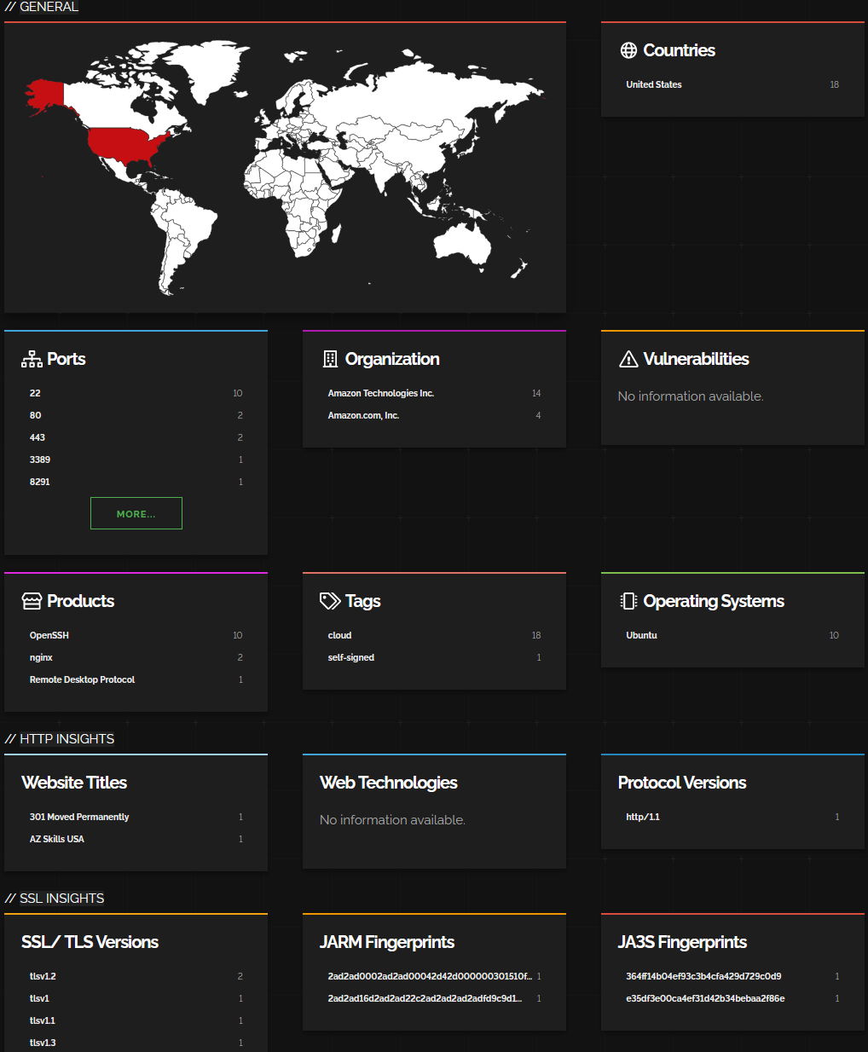
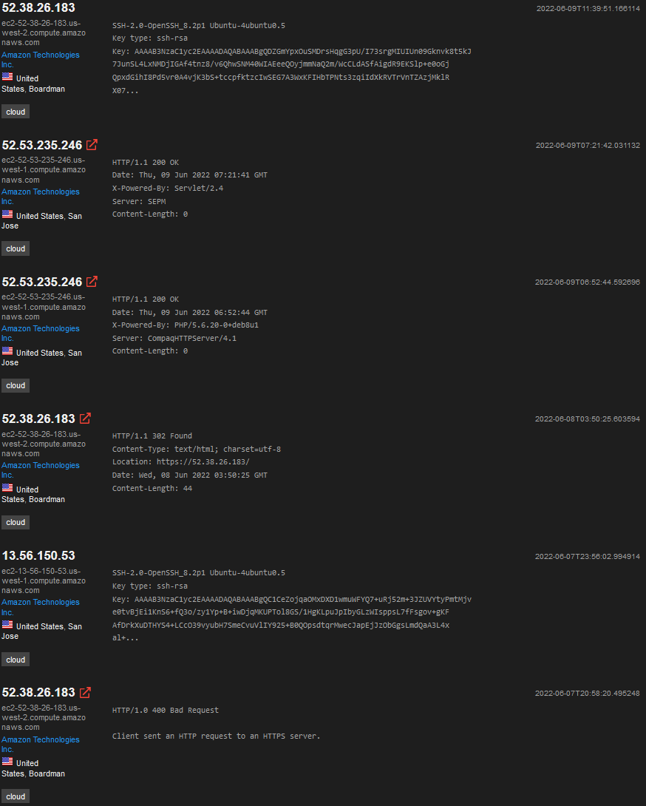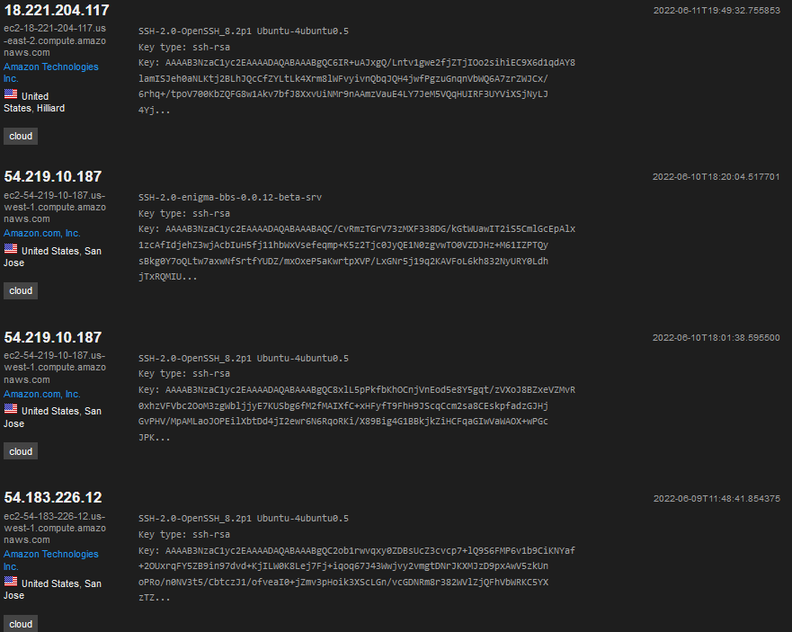
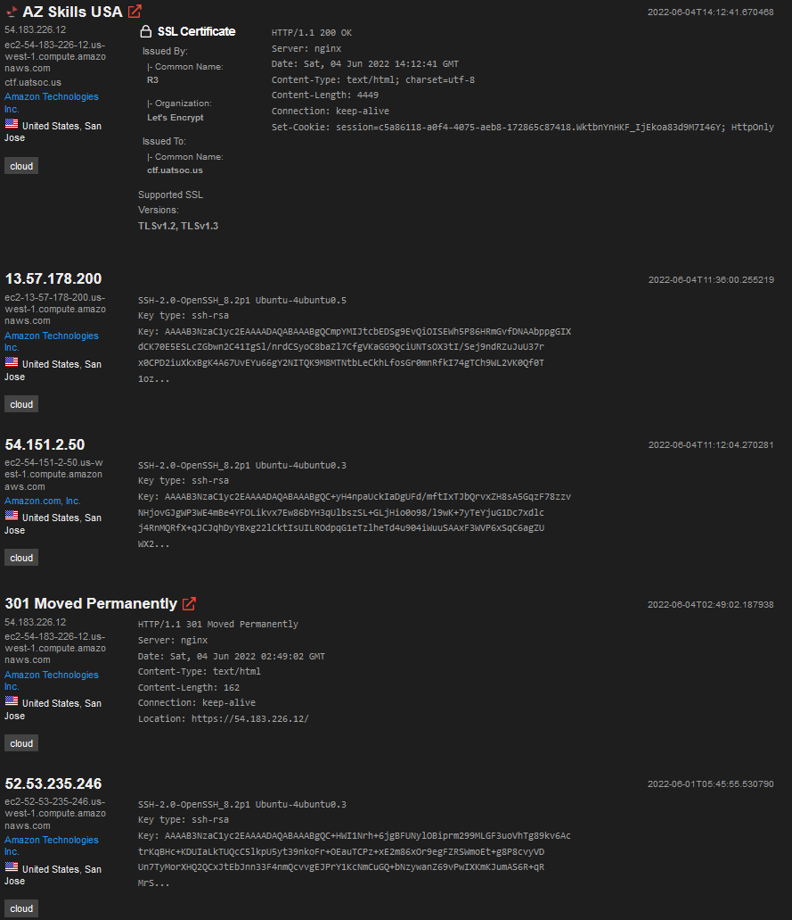

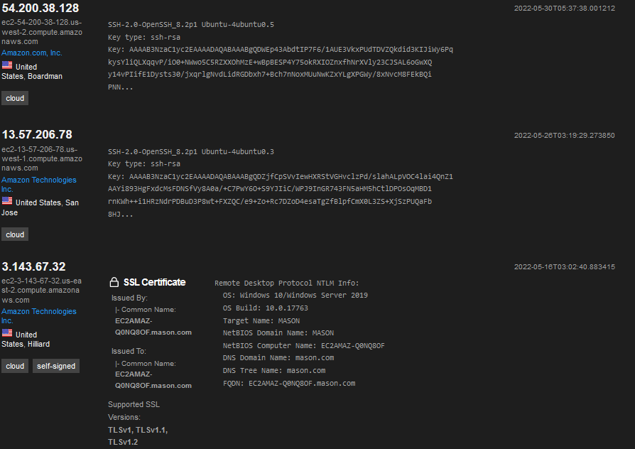

18.221.204.117
Link: https://www.shodan.io/host/18.221.204.117
Hostnames: ec2-18-221-204-117.us-east-2.compute.amazonaws.com
Open ports: 22 (SSH)

54.219.109.202
No information or open ports

54.219.10.187
Link: https://www.shodan.io/host/54.219.10.187
Hostnames: ec2-54-219-10-187.us-west-1.compute.amazonaws.com
Open Ports: 22 (SSH), 8889 (TCP/UDP)

13.56.150.53
Link: https://www.shodan.io/host/13.56.150.53#22
Hostnames: ec2-13-56-150-53.us-west-1.compute.amazonaws.com
Open ports: 22 (TCP)

54.151.2.50
Link: https://www.shodan.io/host/54.151.2.50
Hostnames: ec2-54-151-2-50.us-west-1.compute.amazonaws.com
Open ports: 22 (SSH)

54.183.226.12
Link: https://www.shodan.io/host/54.183.226.12
Hostnames: ec2-54-183-226-12.us-west-1.compute.amazonaws.com, ctf.uatsoc.us
Open ports: 22, 80 (HTTP), 443 (HTTPS)
Note: It’s an AZ Skills USA website
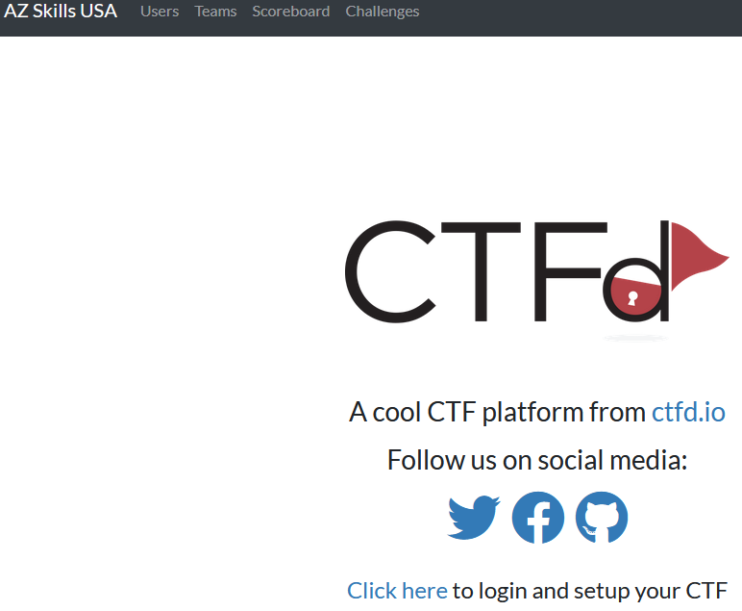
52.38.26.183
Link: https://www.shodan.io/host/52.38.26.183
Hostnames: ec2-52-38-26-183.us-west-2.compute.amazonaws.com
Open ports: 22, 80, 443

52.53.235.246
Link: https://www.shodan.io/host/52.53.235.246
Hostnames: ec2-52-53-235-246.us-west-1.compute.amazonaws.com
Open ports: 22, 8291, 19000

13.57.178.200
Link: https://www.shodan.io/host/13.57.178.200
Hostnames: ec2-13-57-178-200.us-west-1.compute.amazonaws.com
Open ports: 22
54.200.38.128
Link: https://www.shodan.io/host/54.200.38.128
Hostnames: ec2-54-200-38-128.us-west-2.compute.amazonaws.com
Open ports: 22

3.57.206.78
Link: https://www.shodan.io/host/13.57.206.78
Hostnames: ec2-13-57-206-78.us-west-1.compute.amazonaws.com
Open ports: 22

52.53.231.231
Link: https://www.shodan.io/host/52.53.231.231
Hostnames: ec2-52-53-231-231.us-west-1.compute.amazonaws.com
Open ports: 3389 (Remote Desktop)

No results available on Shodan
13.56.229.144, 13.52.96.169, 54.176.155.123, 3.143.67.32, and 54.215.216.238

