Certificate Services
Emily Kellogg
University of Advancing Technology

Certificate Services – VirtualBox Server
22.1 - Installing AD CS Through Server Manager
Adding the AD CS roles and features
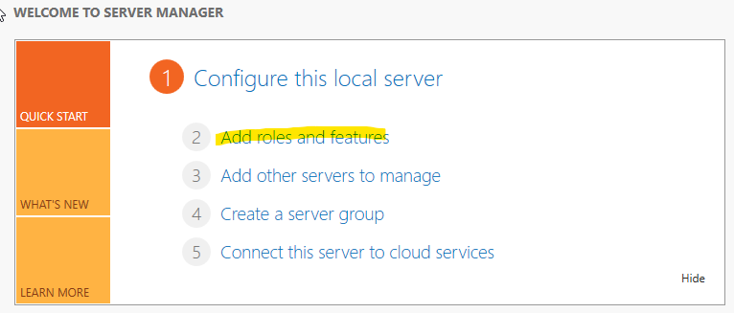
Role-based since I am downloading it on this machine alone.
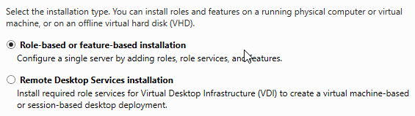
Verifying the roles and features will be added to this machine.
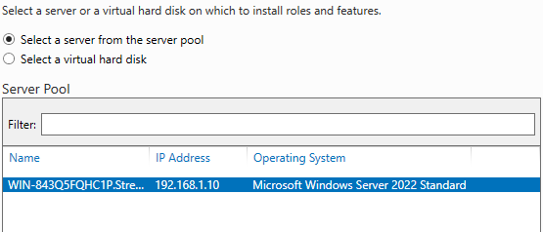
Adding AD CS.
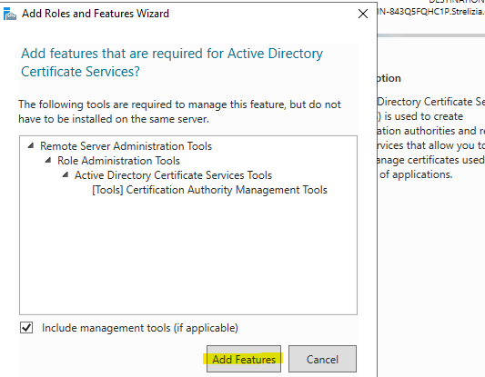
I chose two of these services because they seemed useful for later steps (22.2)
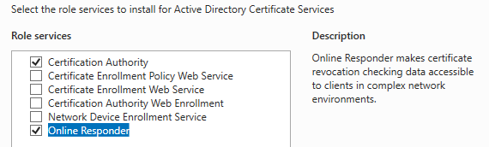
Installation progress:
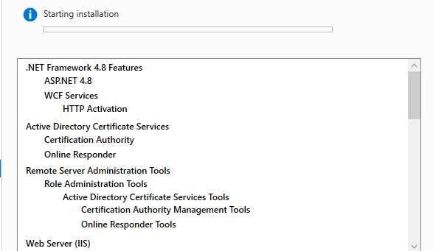
Installation complete!
22.2 - Configuring AD CS Through Server Manager
Now to configure AD CS through the configuration wizard. Here are the role services I chose to configure:
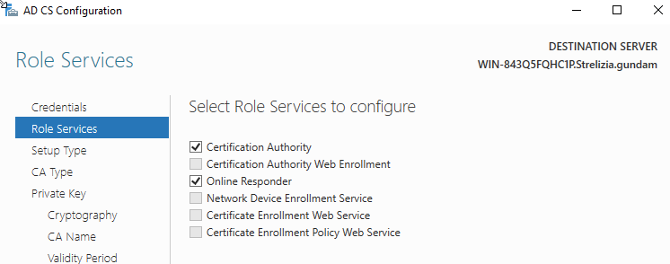
I chose Enterprise CA since I operate online
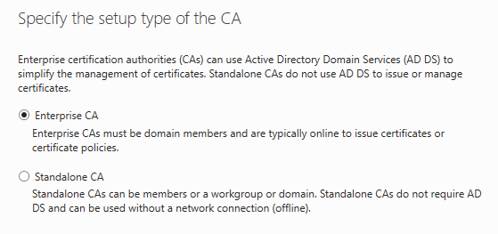
Since I am the main domain controller, I chose Root CA
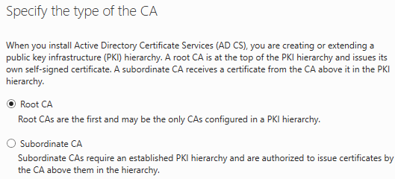
Settings for private key creation:
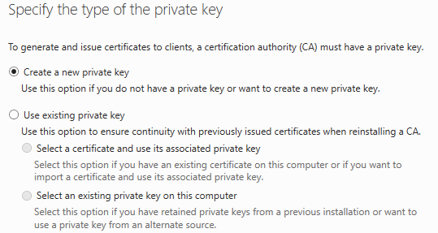
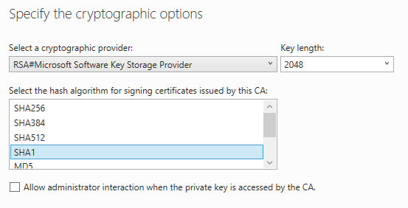
Keeping the default CA name.
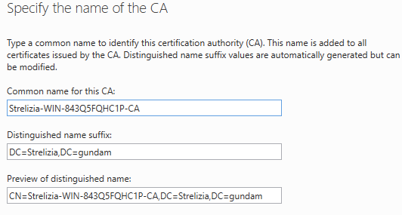
Keeping default validity period.
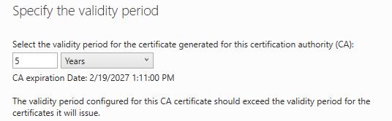
Database locations:
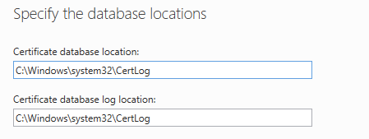
Configuration screen:
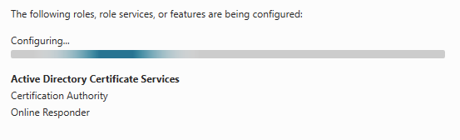
Configuration complete!
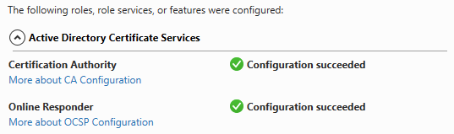
22.3 – Configuring an Auto-Enrollment Group Policy for a Domain
I clicked Start – Administrative Tools – Group Policy Management and was met with this screen:
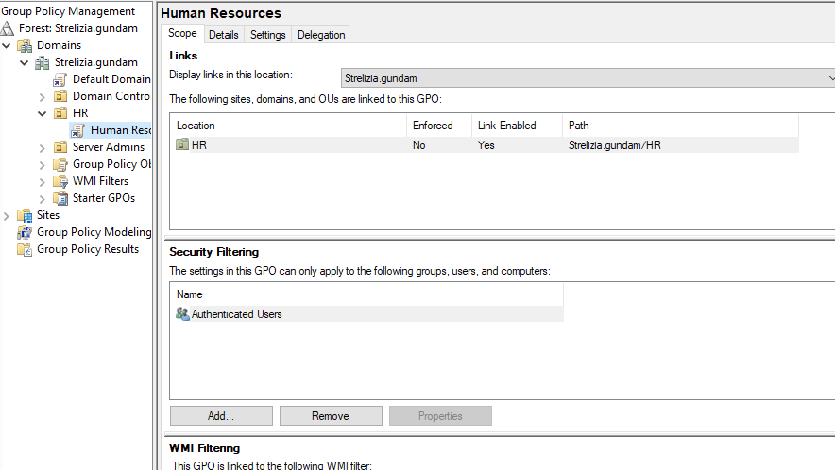
I then right-clicked Default Domain Policy and clicked Edit. This is the screen:
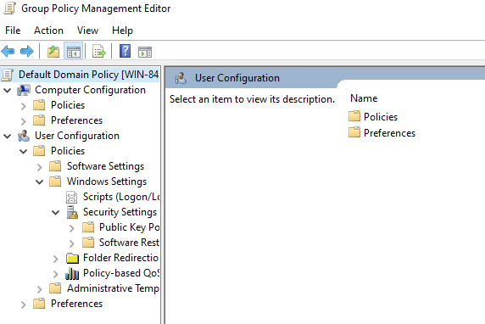
Next, I clicked Public Key Policy and double-clicked Certificate Services Client – Auto-Enrollment. This setting will auto-enroll and renew my certificate services, so I do not have to do it myself.
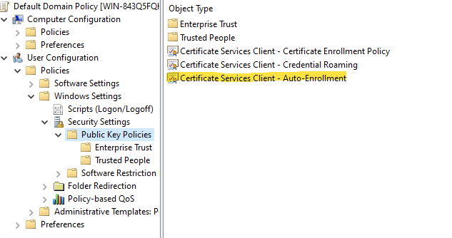
Here are the Certificate Service Client settings:
(Default: no boxes checked)
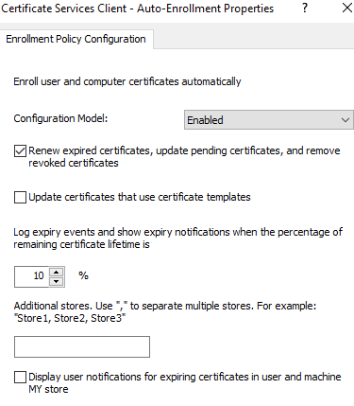
22.4 – Creating a Certificate Template
First, I opened Certificate Authority to access my certificates.
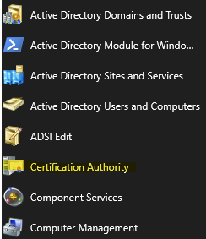
Then, I the CA name, Strelizia, right-clicked Certificate Templates, and clicked Manage.
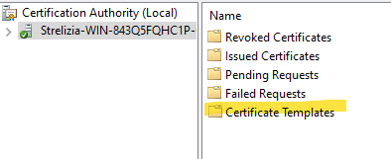
Here are all of the Certificate Templates.
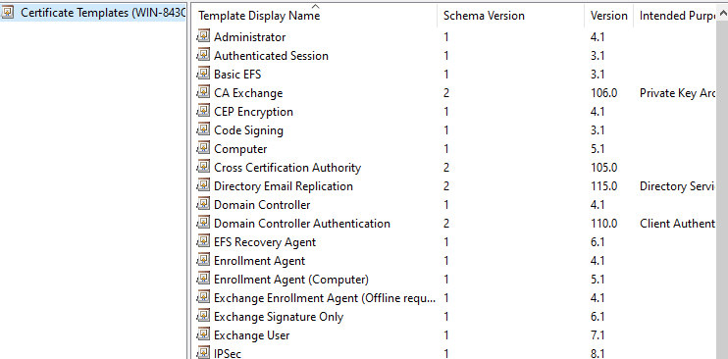
I am going to duplicate a Computer template.
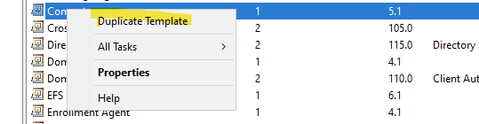
Here are the settings for the duplicate, I changed the default (Server 2003) to Server 2008:
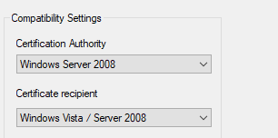
I also gave the duplicate a name, clicked Apply, and closed the windows.
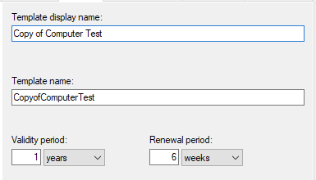
22.5 – Publishing a Certificate Template
I opened the Certification Authority tool for this exercise, then clicked Certificate Templates.
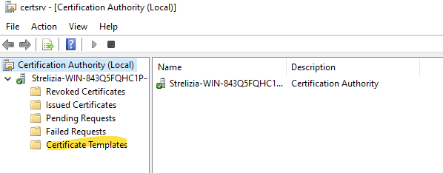
Next, I clicked Certificate Template to Issue since I will be publishing a template.
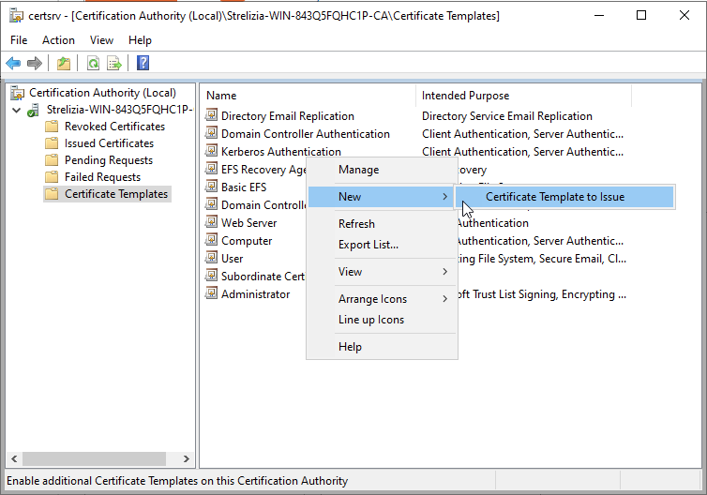
I published my Copy of Computer Test template.
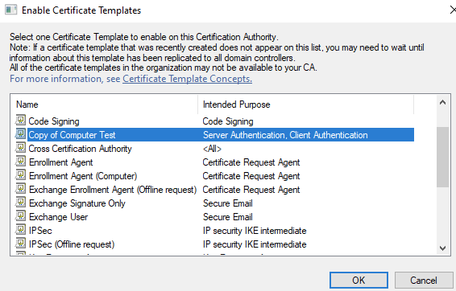
There it is, published!
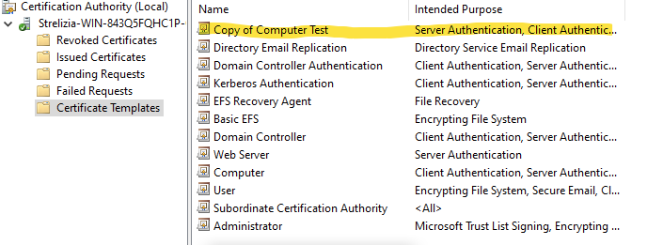
22.6 – Revoking a Certificate
There aren’t any certificates to revoke.
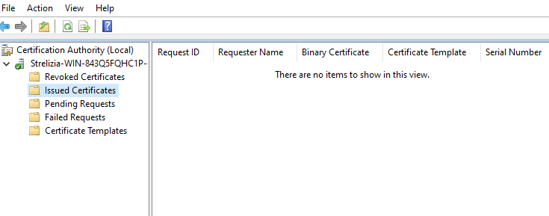
22.7 – Configuring CA Policy Auditing
Part 1: Enable Object Access/Success Auditing in the CA machine’s local security policy
I ran mmc.exe
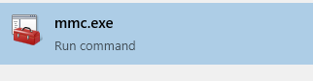
I was met with this screen:
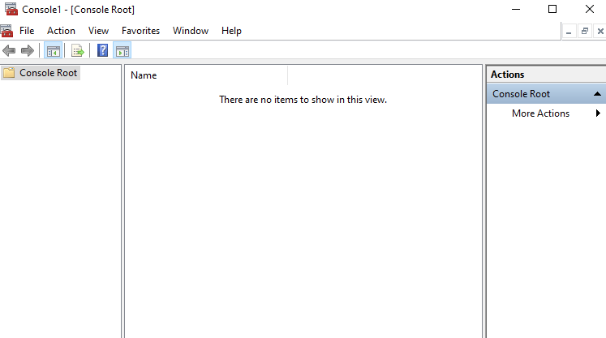
Next, I added a snap-in.
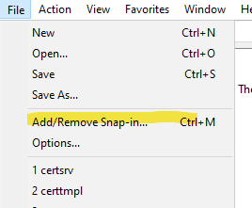
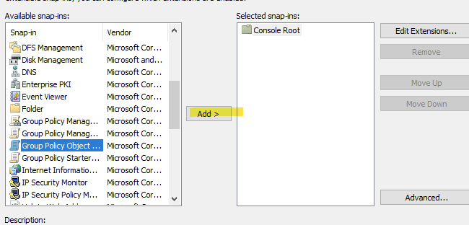
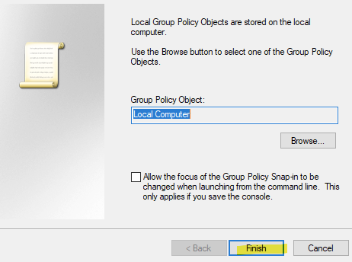
Then, I enabled Success Auditing for Object Access.
Here is the file path:
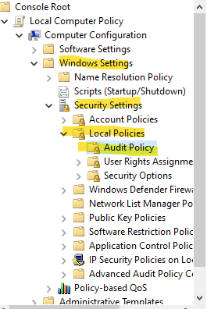
And the policy screen:
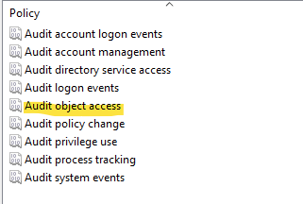
The computer is now auditing success attempts for object access.
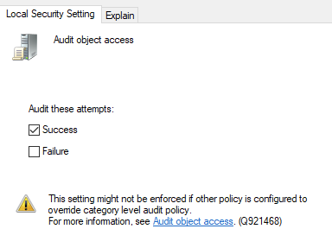
Part 2: Enable auditing on the CA
I opened Certification Authorities and right clicked my CA name.
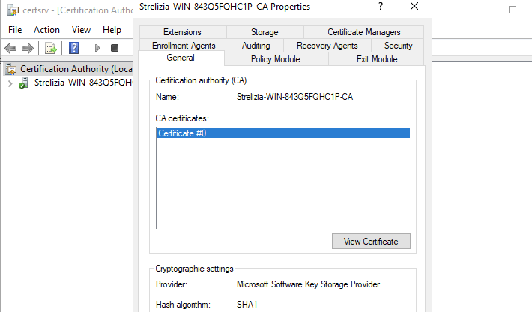
Then, I navigated to the Auditing tab and checked two boxes to audit.
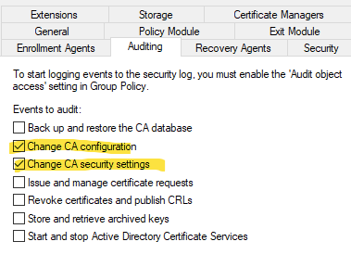
Finally, I clicked Apply and closed all open boxes.
Extras:
I checked the state of my server’s firewall and scanned it.
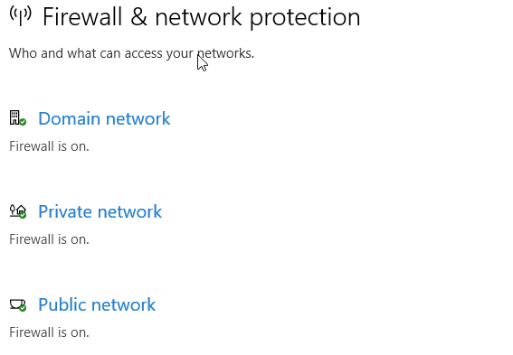
Everything looks good there. Now for the scan.
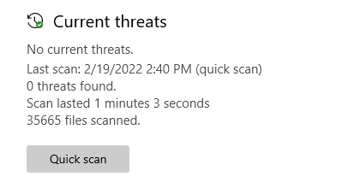
Awesome! Now to check for updates since I leave the server off for long periods of time.
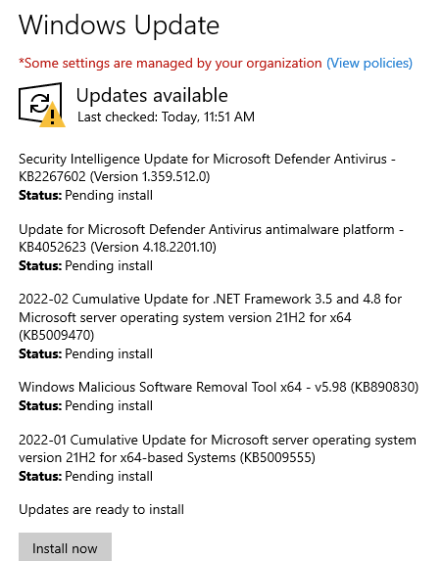
Updates are installed and server is off.

References
JasonGerend, Dknappettmsft, Khdownie, Eross-msft, John-par, Jamesmci, Sudeepku, & Yishengjin1413. (2021, July 29). Configure the server certificate template. Developer tools, technical documentation and coding examples | Microsoft Docs. https://docs.microsoft.com/en-us/windows-server/networking/core-network-guide/cncg/server-certs/configure-the-server-certificate-template
Panek, W. (2018). MCSA Windows Server 2016 complete study guide: Exam 70-740, exam 70-741, exam 70-742, and exam 70-743. John Wiley & Sons.

