Automate Something in Azure
Emily Kellogg
University of Advancing Technology

Automate Something in Azure

Restore a VM From Snapshot (VirtualBox)
This portion of the lab takes place in a VirtualBox environment. Because I use this VM regularly, there are several snapshots I can use to restore it.
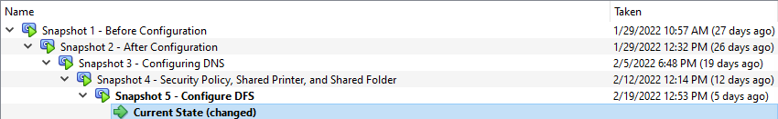
Here is a screenshot of the VM’s current state (Snapshot 5). This is important because certain features of the server will change when I restore a different snapshot.
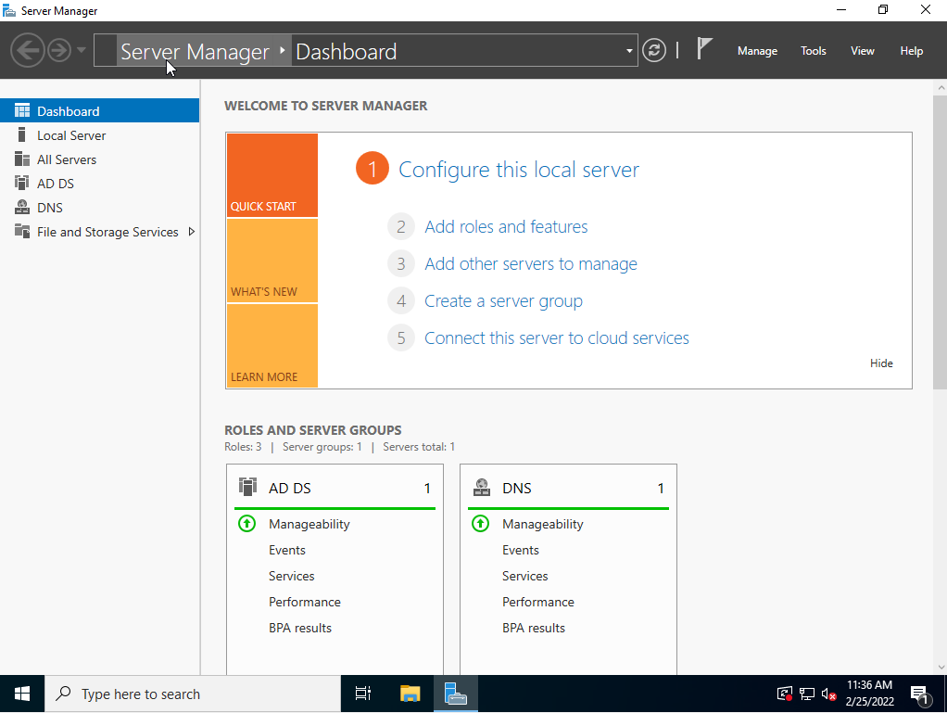
This screenshot is also of the VM’s current state, but with the Tools menu open. I screenshotted this to point out differences between the Current State and VM’s restored snapshot state.
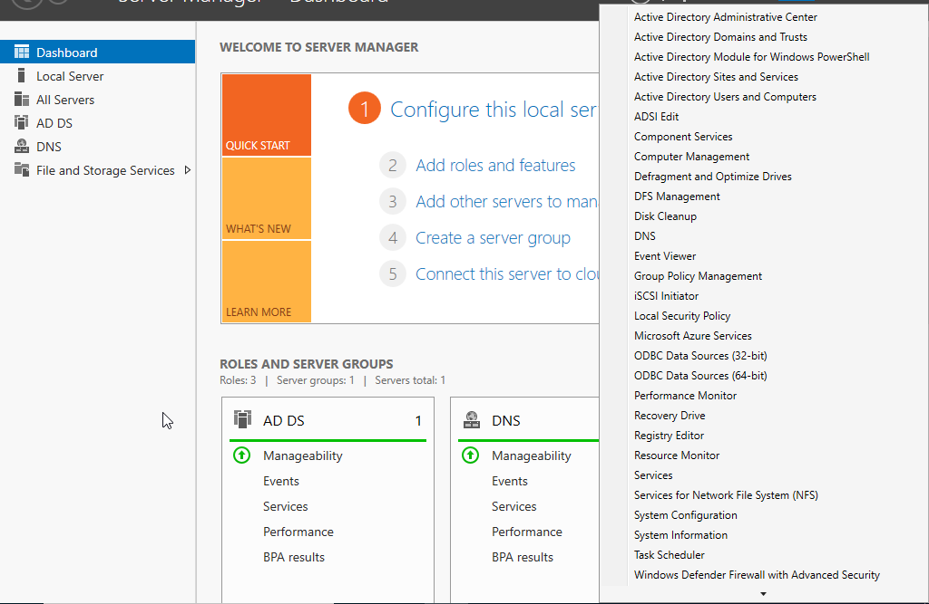
Screenshots of the restore process: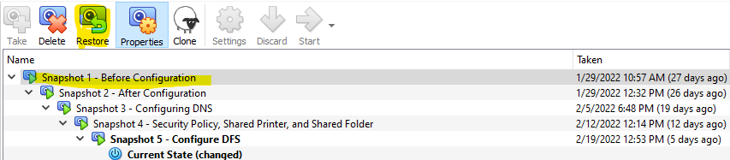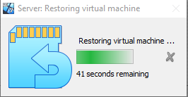
Here is a screenshot of Snapshot 1 – Before Configuration, the snapshot I chose to restore the VM from. The number of tools available is very different than Snapshot 5’s VM. This is because Snapshot 5 is the latest snapshot, containing all the configuration settings and various roles I added whilst doing assignments.
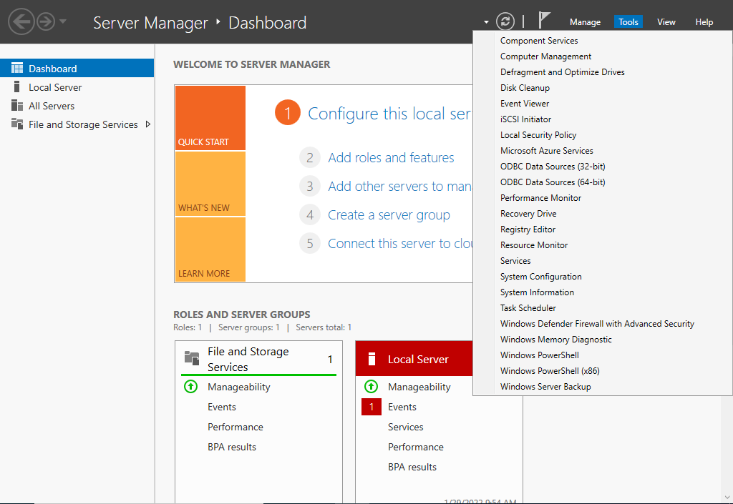

Deploy a VM From Template
This is the next portion of the lab where I create a Template through Azure and deploy a VM from it.
Since I’ve never done this before, I’m starting from scratch! First, I need to create a storage account. Below are screenshots of that process.
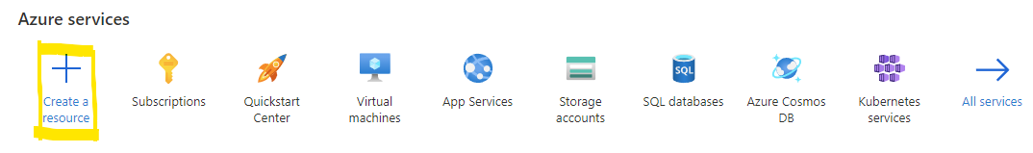
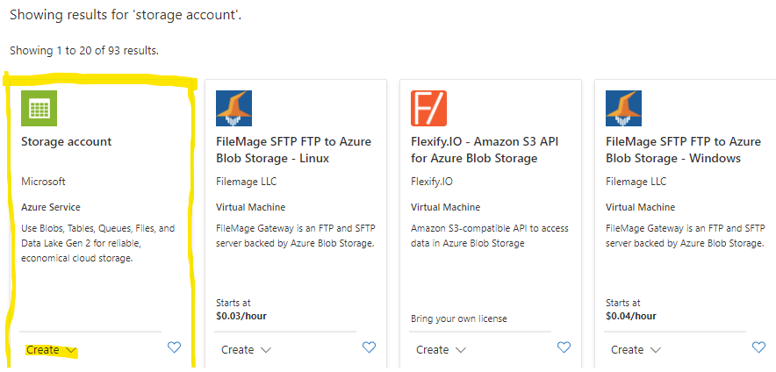
Next, I need to fill out the “Basics” of my new storage account. Screenshots of this process follow.
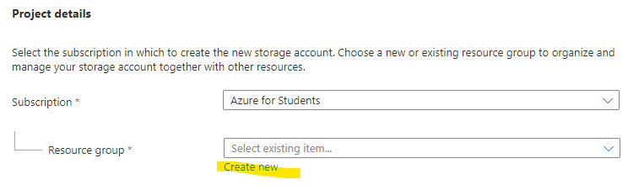
This is the unique name (resource group) I chose for my storage account:
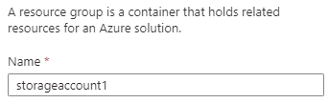
I left the default settings alone and clicked Review + create. After waiting for validation to pass, I clicked Download a template for automation.
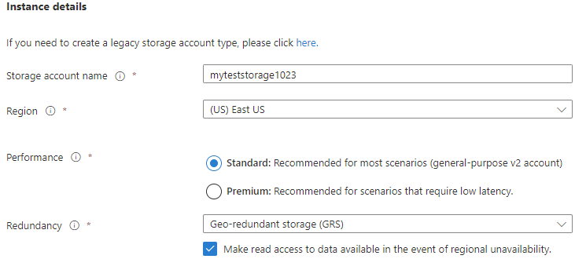
Settings for the new storage account:
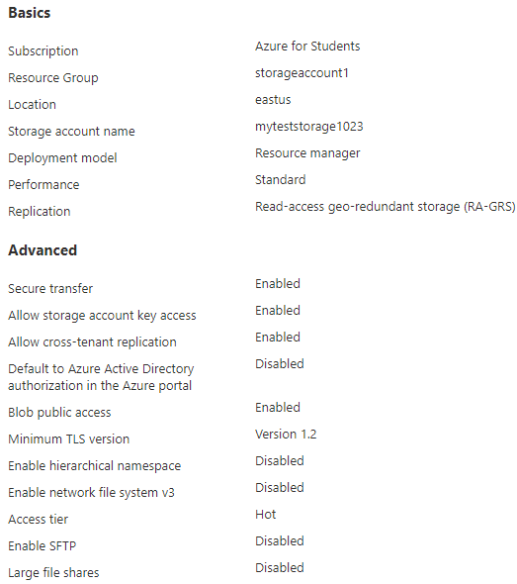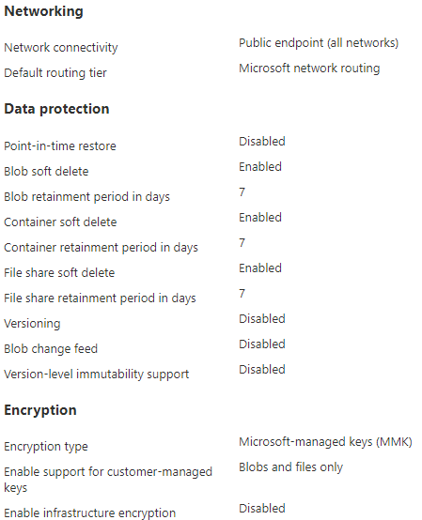
Here is the template I downloaded. It’s long so I only screenshotted a part of it. The final steps for this portion of the lab include downloading the template to my computer, editing it, and deploying it for automation.
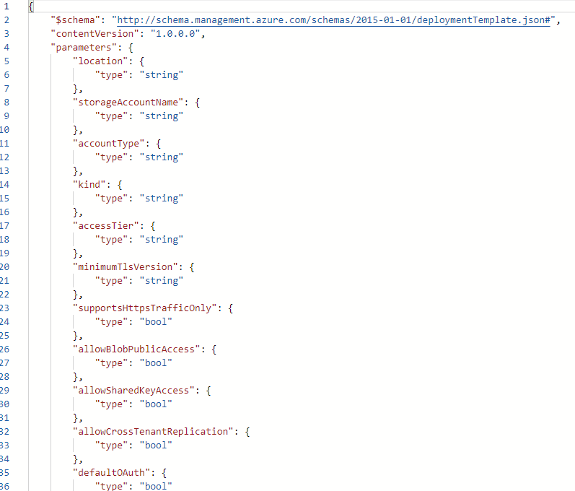

Editing and Deploying the Template
Before editing, I successfully downloaded and saved the template to my computer. These are the screenshots from that process:
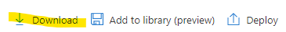
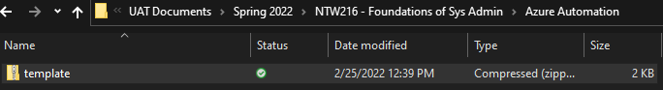
I also wrote down values from the Parameters tab for later. Here they are:
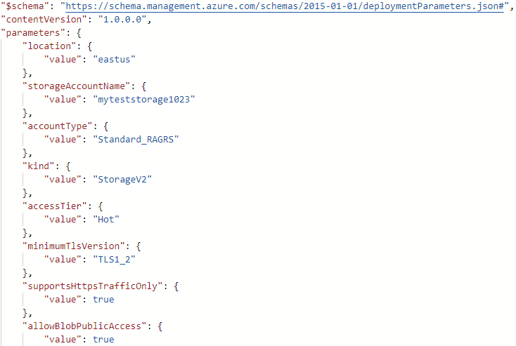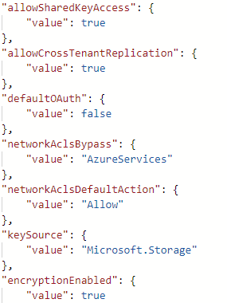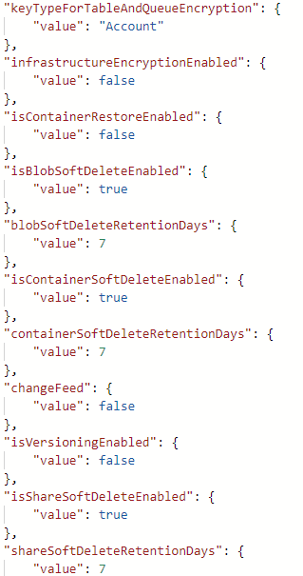
Now for the editing process. Deploy a custom template will be used to edit the template’s code.
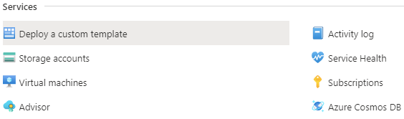
Build your own template in the editor allows me to load the .json file (my template) into the editor for manipulation.
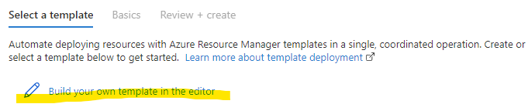
Here is a partial screenshot of my template in the editor.
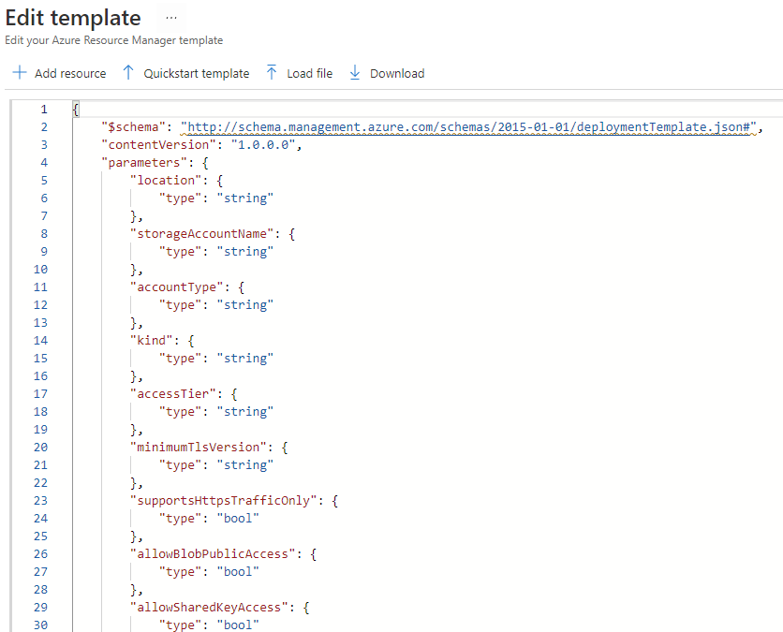
Only three changes need to be made to the code: removing the storageAccountName line, adding the storageAccountName variable, and updating the name variable to storageAccountName.
Screenshots of those edits (before: top, after: bottom):
Edit #1: removing the storageAccountName parameter.
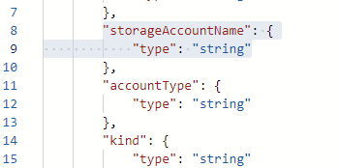
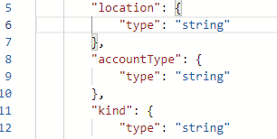
Edit #2: creating the storageAccountName variable.
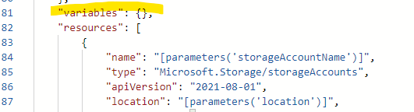
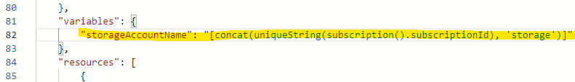
Edit #3: update the name element of the storageAccounts resource to the name of the variable in Edit #2.
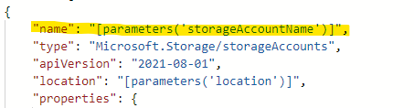
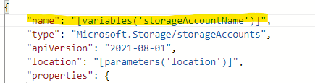
The point of these edits was to change storageAccountName from a parameter to a variable. I believe this was done because parameters are normally constants while variables can change. Change is important here because file names can change and will not always remain constant.
Once the edits were made, I saved the template. Here are the Instance details I defined for the template:
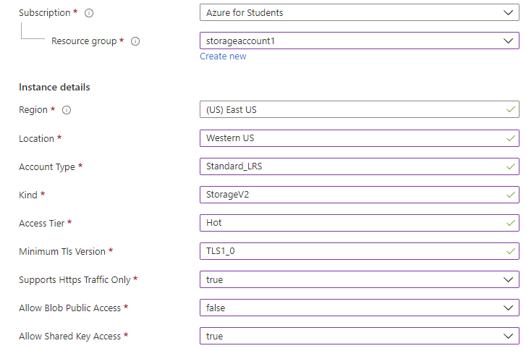

These Instances were filled out using the values from the Parameter tab.
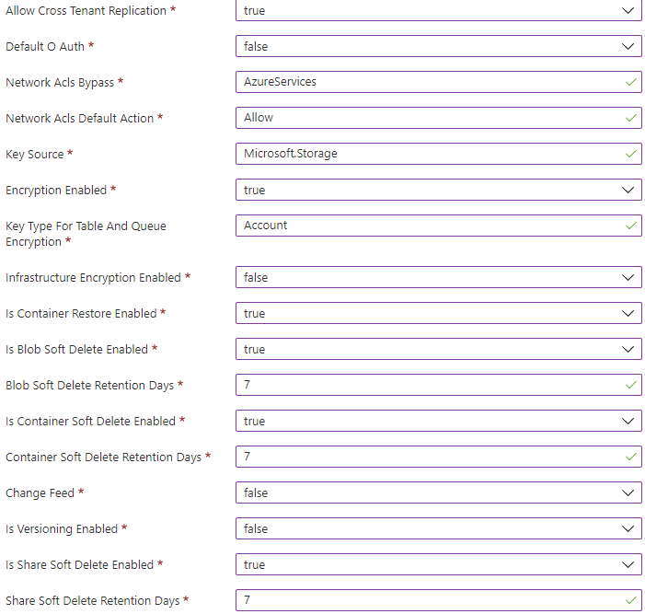
After Instances were filled out, I clicked Review + create, waited for validation to complete, clicked Create, and waited for Deployment.
Deployment was successful!
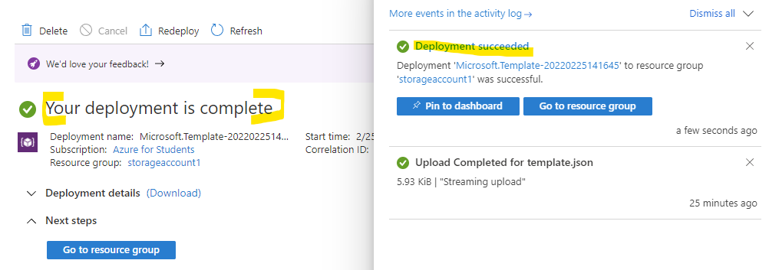
This is the storage account within the resource group I created (its name was generated, not given by me):
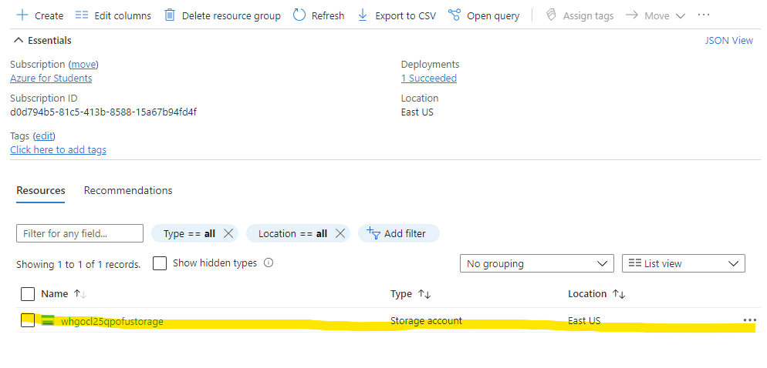

Create an Azure Pipeline
The final portion of this lab takes place in Azure DevOps. I’ve never used it before, so I had to create a project before continuing with the exercise. I also had to create a GitHub account. Both resources will be used to create a pipeline.
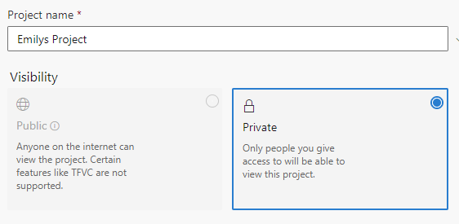
After creating those accounts, I ran the template provided in the instructions (Microsoft, 2022).
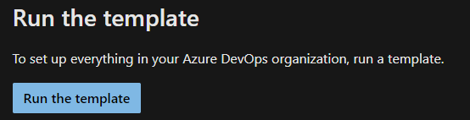
This is the screen that shows after running the template. Let’s go look at the project!
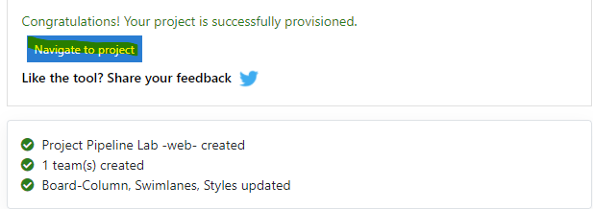
This is the project page. It is empty because I am the only one working on the project. Take note of the Boards tab as that is where I will be going next.
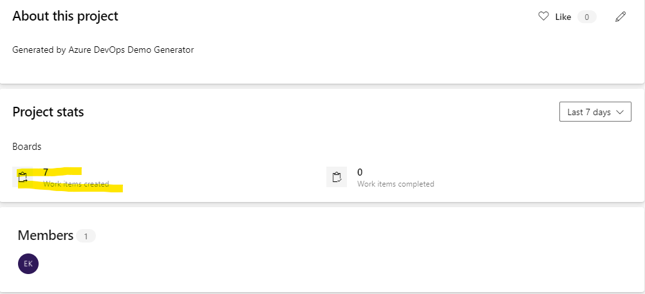
Now it’s time to assign work to myself and start on the project. Here is my board:
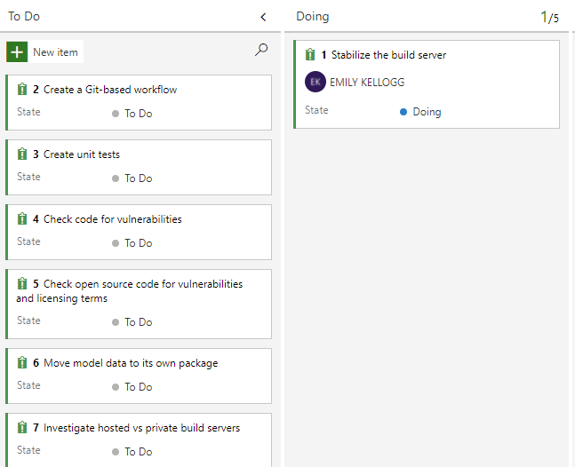
Next is the pipeline! I had to create one because its my first time making one.
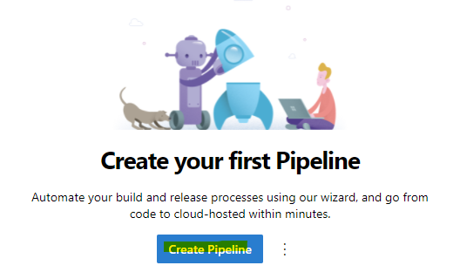
Since my code will be in GitHub, I clicked GitHub on the Connect page.
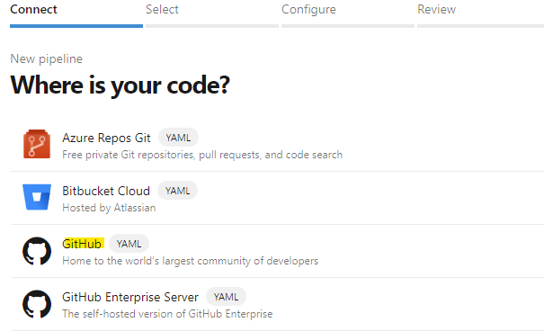
The repository is in my newly created GitHub account named 002Strelizia.
Note: before starting this project, I added the Space Game project given in the instructions to my GitHub.
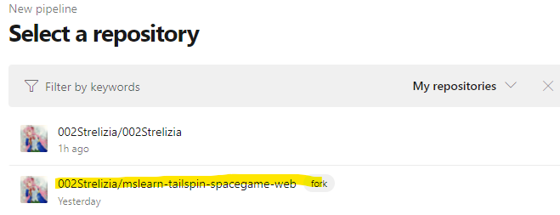
Pipeline is through ASP.NET since the code uses .NET Framework.
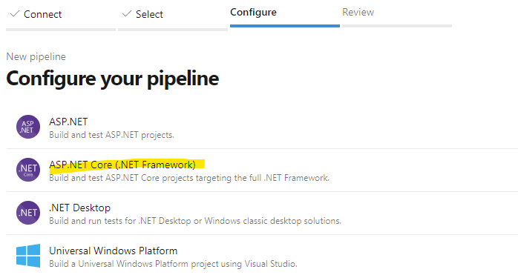
A screenshot of my project’s code:
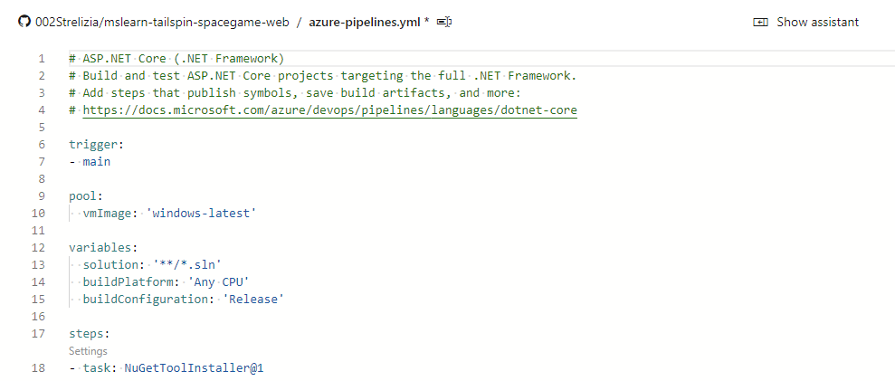
And finally, the pipeline has been created. I cannot go any further than this without filing for a free parallelism grant…
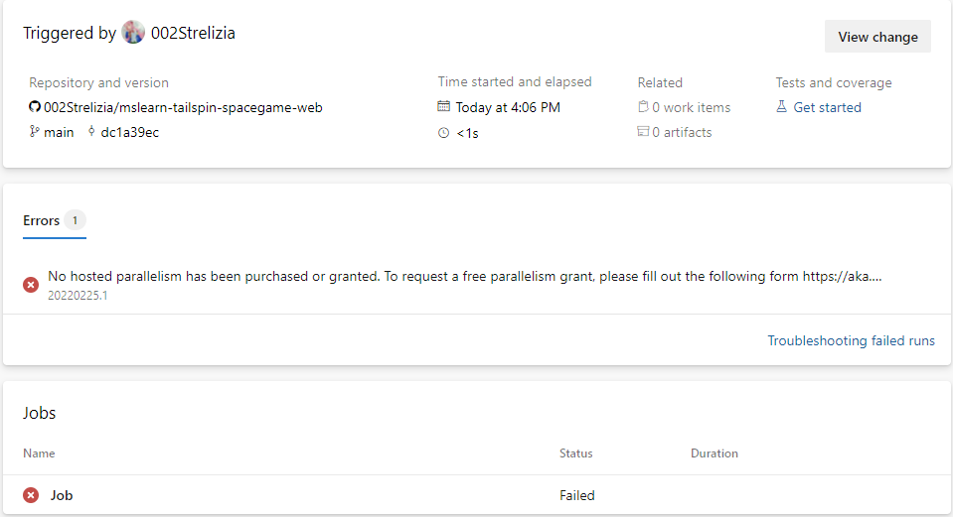

Extra – Some Fun in GitHub!
Creating a Repository
This is my private GitHub repository named a-new-repository. I added a README file so I can concisely describe my project. If I need to in the future, I will add a license as well, so people know how they can use my code.
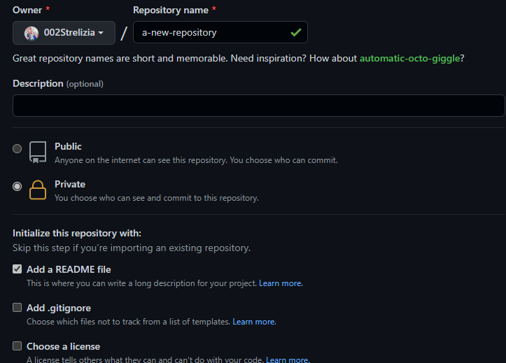
These are the current repositories in my GitHub account. I am going to fidget with the Space Game code in Visual Studio so I can get it to run properly.
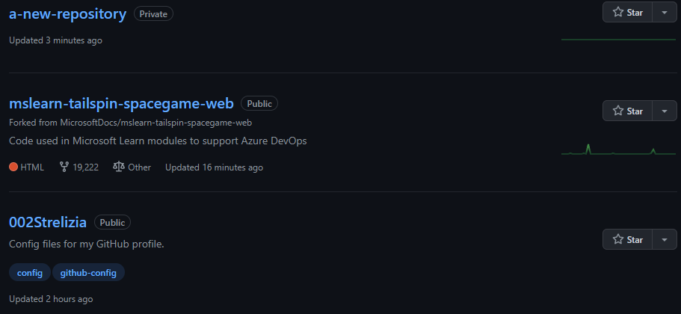
Opening the Space Game code in Visual Studio:
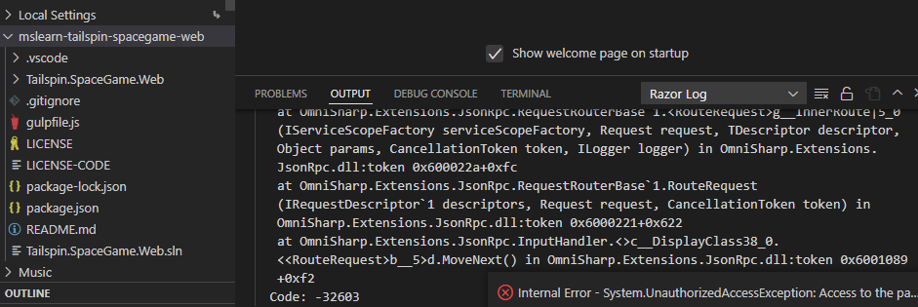
After some coding I successfully ran Space Game in my web browser! The black box in the screenshot is my Visual Studio code.
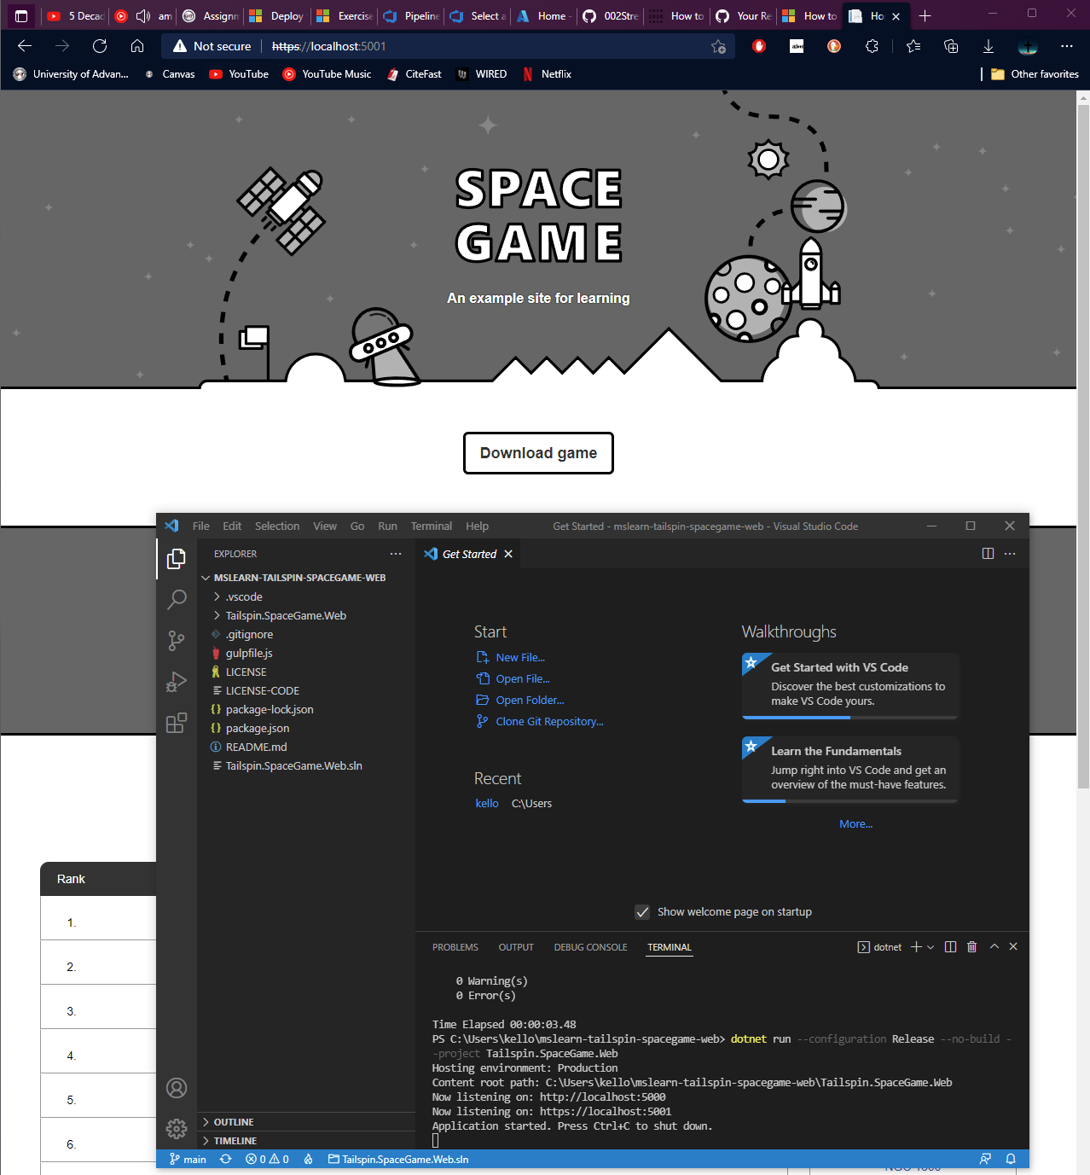
Here is the code in a better screenshot. In short, it takes the Space Game file from GitHub and launches it in a browser. Unfortunately, the website is unsecured (HTTP).
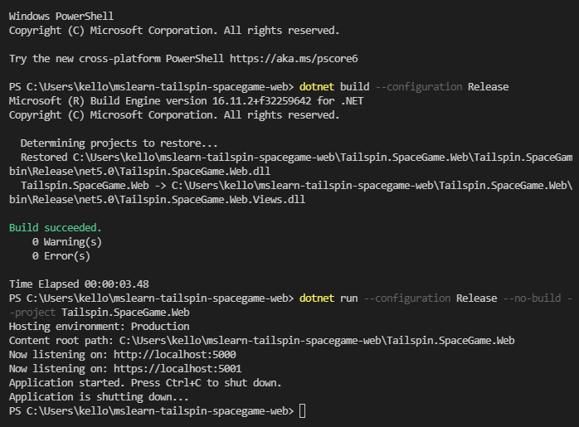
This concludes my lab!

References
Chw-6489. (2021, July 15). How to resolve "No hosted parallelism has been purchased or granted" in free tier? - Microsoft Q&A. Developer tools, technical documentation and coding examples | Microsoft Docs. https://docs.microsoft.com/en-us/answers/questions/477716/how-to-resolve-34no-hosted-parallelism-has-been-pu.html
Mumian, Alexbuckgit, V-kents, Davidsmatlak, Damabe, & Tfitzmac. (2021, December 13). Deploy template - Azure Portal - Azure resource manager. Developer tools, technical documentation and coding examples | Microsoft Docs. https://docs.microsoft.com/en-us/azure/azure-resource-manager/templates/quickstart-create-templates-use-the-portal
Petchel, T., Microsoft Open Source, Jamcneil, Stijnlegtenberg, & Microsoft GitHub User. (n.d.). MicrosoftDocs/mslearn-tailspin-spacegame-web: Code used in Microsoft learn modules to support Azure DevOps. GitHub. https://github.com/MicrosoftDocs/mslearn-tailspin-spacegame-web
Steved0x. (n.d.). Create a build pipeline with Azure Pipelines. Developer tools, technical documentation and coding examples | Microsoft Docs. https://docs.microsoft.com/en-us/learn/modules/create-a-build-pipeline/1-introduction

