Create OUs, Users, a Security Policy, Shared Folder, and Shared Printer
Emily Kellogg
University of Advancing Technology

Creating OUs, Users, a Security Policy, Shared Folder, and Shared Printer

Editing Network Settings
These setting aren’t a part of this assignment, but the last one. I misconfigured the network with information I found online when I should have used my own network information.
Reminder: Please add points back to my previous assignment!
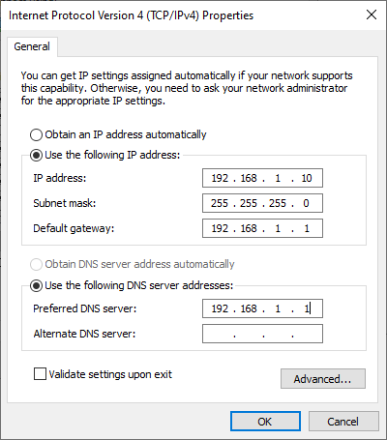
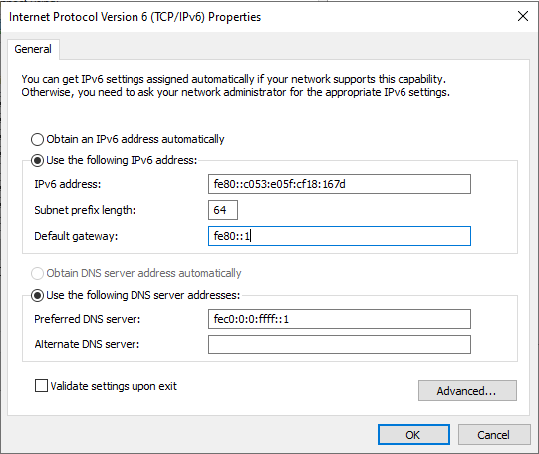

Creating OU
OUs are containers where specific policies are applied. In this case, I am creating a container for Server Admins and HR, so their policies are separated and not shared.
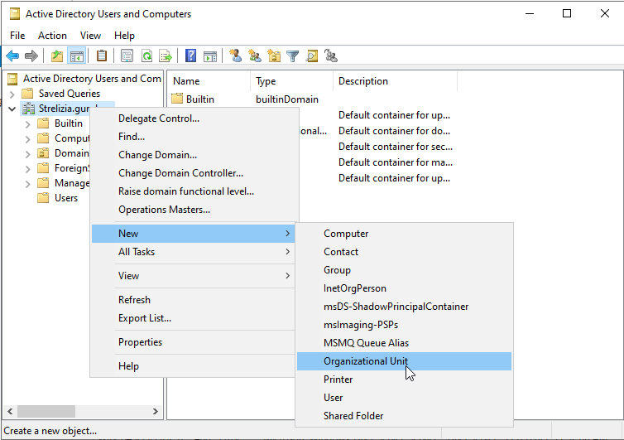
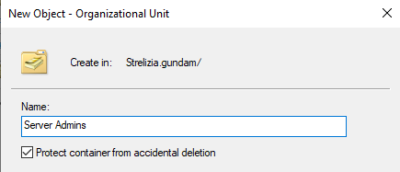
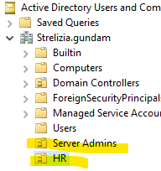

Creating Users
I am creating a user in the HR OU because I do not want to do work twice. Instead of creating a general user and moving it to HR, I am creating it in the HR OU, so those policies apply to it without extra work.
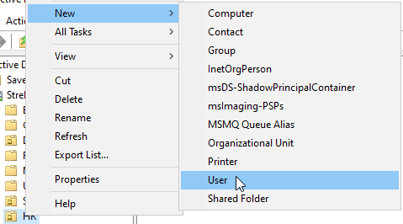
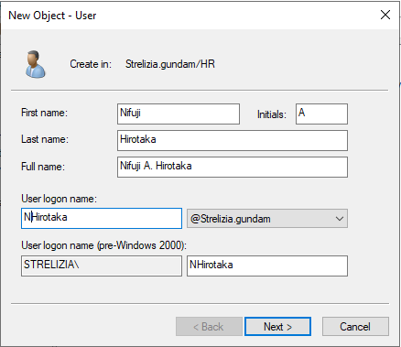
Password never expires because I won’t be touching this account and I don’t want to have to keep rechanging the password.
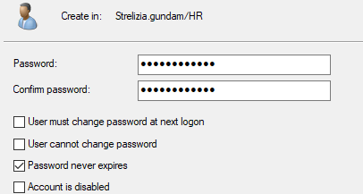
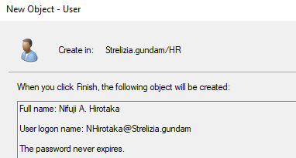
Here is my newly created user within the HR OU.

Creating a Security Policy
Here is the Default Domain Policy:
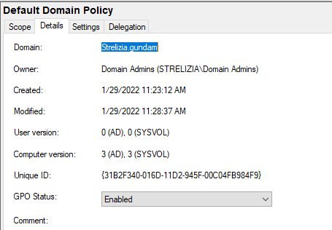
Creation of Group Policy for HR:
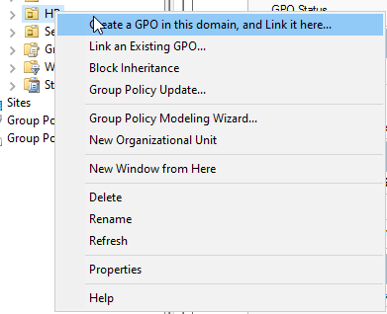
Here is the created Human Resources GPO in the HR OU.
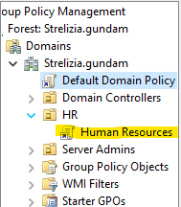
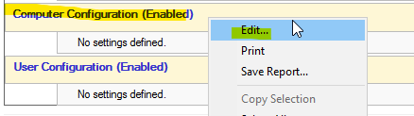
Example Audit Policy of logging successful attempts. Not going to log failed attempts because attackers can take advantage of that.
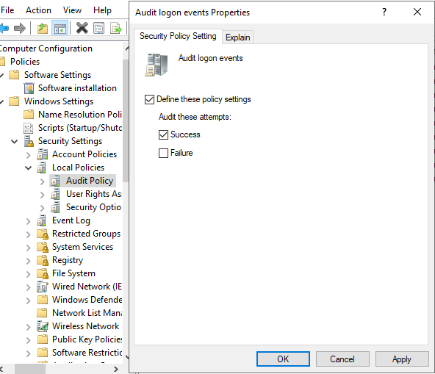
Security Options:
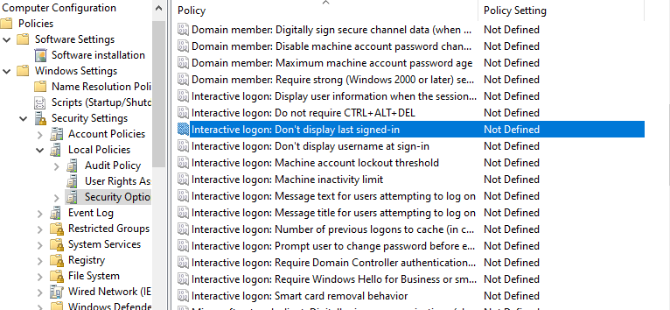

Enabled “Don’t display last signed-in” because that can give malicious users more information than they need.

Creating a Shared Folder
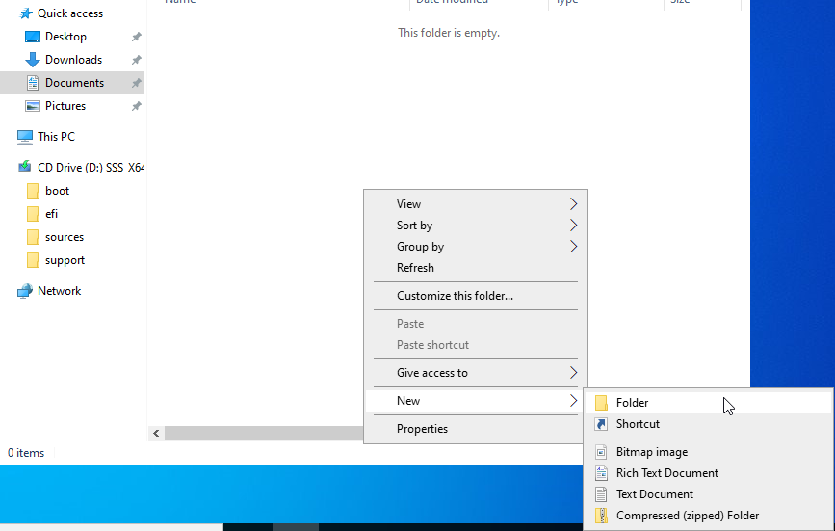
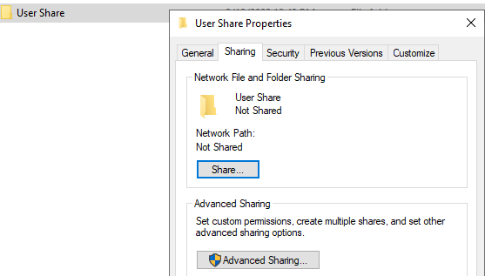
User Share Advanced Sharing properties:
Limited simultaneous users to 100. As an example, I will assume that I have 100 people in my company who need access to this folder.
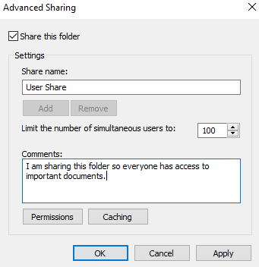
Changed the permissions from Everyone having access to only Domain Users having access.
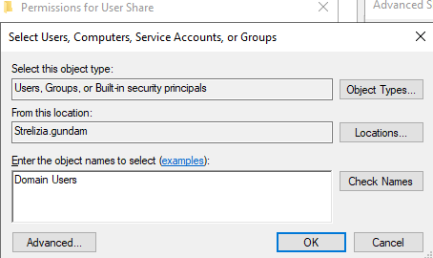
I removed Everyone and replaced it with Domain Users. Now, only Domain Users have access to the folder with Read and Change permissions.
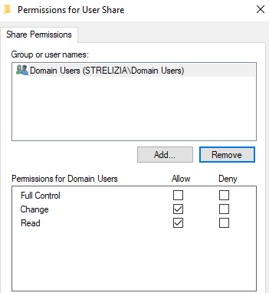
Here is the completed product:
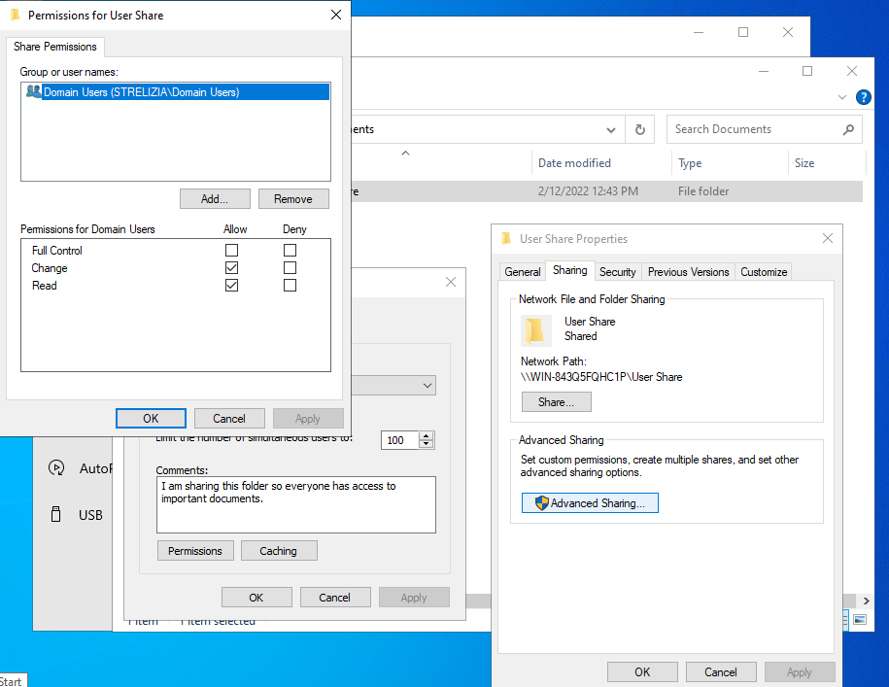

Creating a Shared Printer
Since I don’t have an actual printer, I created an example one for reference. It’s called Microsoft MS-XPS Class Driver 2. Here are the share settings for it:
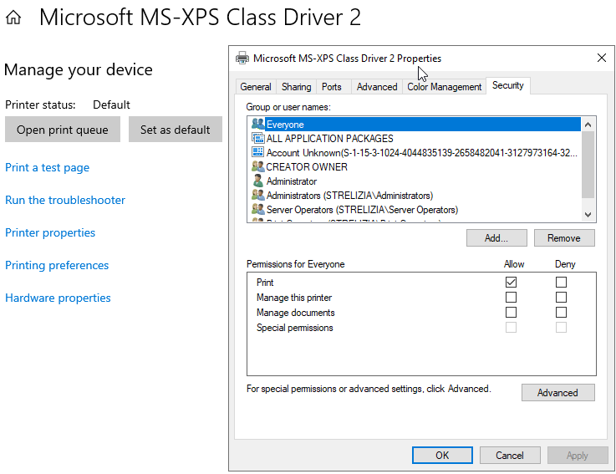
I removed Everyone and added Domain Users. Giving Everyone access is dangerous because that means anyone on your network or using your computers can access the printer.
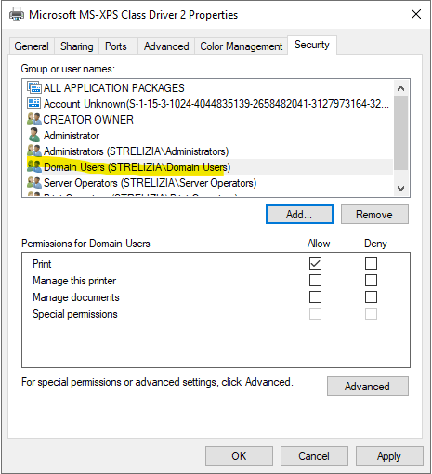
If I wanted to get super specific, I would add permissions to OUs giving special people more access to the printer than others. For example, I would give the System Admin permissions like “manage this printer” and “manage documents”, while I would give an employee general permissions like “Print” and possibly “Manage documents”.
Here is the printer I created for reference:
